Group symbol: 2
Team: 1

Project title: ListItUp

Team members (filled by PM, Team Leader):
No | Name | Surname | Student ID | Role
1 | Carmelo | Romero Pérez | 293936 | PM, Team Leader
2 | Álvaro | Puebla Ruisánchez | 293867 | Team member
3 | Carmen | Gutiérrez Sánchez | 293906 | Team member
4 | David | Sosa Domínguez | 293885 | Team member
5 | Diego | García Agrelo | 293939 | Team member
6 | Miryam | Merchán León | 293907 | Team member

- Construction and tests (S4)
  - Implementation
The documentation focuses on the implementation of the software in the form of programming language source codes. You should prepare lists of created artefacts, i.e., source codes, configuration files, files containing program resources, pre-requirements, and result programs. You should supplement the list of artefacts with a description indicating the relationships between them and their nature (type), as well as technical requirements in the scope of their use. The implementation should cover the minimum viable product (MVP) of the system.
The presentation of the application execution is a must for obtaining a positive grade.
This section documents the software implementation of ListItUp, covering source code, configuration files, resource files, and result artefacts. It describes how the deliverables relate to technical and functional requirements, and confirms the scope of the Minimum Viable Product (MVP). A live deployment of the application is accessible at https://listitup.duckdns.org

4.1.1. Overview
ListItUp is a web-based social list-curation platform that allows users to create, share, and discover ranked lists about any topic. The system is implemented as a server-rendered monolith: a single Spring Boot application serves both the REST API and the Thymeleaf-based frontend, with all persistent state held in a PostgreSQL database.
The backend follows a layered architecture with clear separation of concerns: Controller layer (HTTP routing and view resolution), Service layer (business logic), Repository layer (data access via Spring Data JPA), and Model layer (JPA entities). Spring Security manages authentication via OAuth 2.0 (Google and GitHub) and enforces role-based access control across STANDARD, VERIFIED, and ADMIN roles. The frontend is rendered server-side using Thymeleaf templates, supplemented with Vanilla JavaScript for dynamic interactions. Containerisation is handled by Docker Compose, which orchestrates the Spring Boot application and the PostgreSQL database as isolated services.

4.1.2. Technology Stack
Backend:
Component | Technology / Version
Language | Java 17
Framework | Spring Boot 3.x
Web layer | Spring MVC (server-rendered, Thymeleaf views)
Data access | Spring Data JPA / Hibernate ORM
Security & Auth | Spring Security 6 + OAuth2 Client (Google, GitHub)
Database driver | PostgreSQL JDBC (pg)
Email | Spring Boot Starter Mail (Jakarta Mail / SMTP)
Input validation | Jakarta Bean Validation (Hibernate Validator)
Actuator | Spring Boot Actuator (health probe for Docker healthcheck)
Language | Java 17

Frontend:
Component | Technology / Version
Templating engine | Thymeleaf 3 (server-side rendering)
Markup | HTML5
Styles | CSS3 (custom, no external framework)
Scripting | Vanilla JavaScript (ES6+)

Build & Deployment:
Component | Technology / Version
Build tool | Apache Maven 3.x (pom.xml)
Containerisation | Docker + Docker Compose
Base images | maven:3-eclipse-temurin-17 (build stage), eclipse-temurin:17-jre-alpine (runtime)
Database | PostgreSQL 15 (postgres:15-alpine)
Production domain | listitup.duckdns.org (DuckDNS dynamic DNS)
SSL/TLS | Let's Encrypt certificate (via reverse proxy / host-level configuration)

4.1.3. Artifacts List

A. Source Code Artifacts
Entity Layer (backend/src/main/java/com/listitup/api/model/)
File | Type | Description | Dependencies
User.java | JPA Entity | Platform user. Holds id, username, email, biography, profilePicture, role enum (STANDARD / VERIFIED / ADMIN), OAuth2 provider id, createdAt. | —
CuratedList.java | JPA Entity | A named, ordered list owned by a User. Fields: id, title, description, coverPhoto, visibility (PUBLIC / PRIVATE), createdAt. ManyToOne → User; OneToMany → Item, Comment, Like. | User, Category
Item.java | JPA Entity | A single entry inside a CuratedList. Fields: id, title, description, externalUrl, photo, positionIndex. ManyToOne → CuratedList. | CuratedList
Category.java | JPA Entity | Taxonomy for lists. Fields: id, name, icon. OneToMany → CuratedList. | —
Comment.java | JPA Entity | User comment on a list. Fields: id, text, timestamp. ManyToOne → User, CuratedList. | User, CuratedList
Like.java | JPA Entity | Like given by a User to a CuratedList. Fields: id, timestamp. Unique constraint on (user, list). | User, CuratedList
Follow.java | JPA Entity | Directed follow edge. Fields: id, follower (User), following (User), timestamp. Represents User→User M:N. | User
Notification.java | JPA Entity | In-app notification. Fields: id, message, isRead, timestamp, type. ManyToOne → User (recipient). | User
Report.java | JPA Entity | Content report. Fields: id, reason, status enum (OPEN / REVIEWED / RESOLVED), timestamp. ManyToOne → User (reporter). | User
Repository Layer (backend/src/main/java/com/listitup/api/repository/)
File | Type | Description | Dependencies
UserRepository.java | JPA Repository | CRUD + custom queries: findByEmail, findByUsername, search by partial name. | User
CuratedListRepository.java | JPA Repository | CRUD + paginated queries for feed (public lists by recency/relevance) and search by keyword and category. | CuratedList, Category
ItemRepository.java | JPA Repository | CRUD + findByCuratedListOrderByPositionIndex for ordered item retrieval. | Item, CuratedList
CategoryRepository.java | JPA Repository | CRUD + findAll for category seed data. | Category
CommentRepository.java | JPA Repository | CRUD + findByCuratedListOrderByTimestampDesc. | Comment, CuratedList
LikeRepository.java | JPA Repository | CRUD + existsByUserAndCuratedList + countByCuratedList. | Like, User, CuratedList
FollowRepository.java | JPA Repository | CRUD + findByFollower, findByFollowing for social graph traversal. | Follow, User
NotificationRepository.java | JPA Repository | CRUD + findByRecipientOrderByTimestampDesc + markAllAsRead. | Notification, User
ReportRepository.java | JPA Repository | CRUD + findByStatus for admin moderation queue. | Report

Service Layer (backend/src/main/java/com/listitup/api/service/)
File | Type | Description | Dependencies
UserService.java | Service | Profile management: update bio/picture, role promotion, GDPR export and account deletion. | UserRepository
ListService.java | Service | List CRUD, visibility toggling, cover photo handling (upload to /app/uploads volume), feed and search pagination. | CuratedListRepository, CategoryRepository, ItemRepository
ItemService.java | Service | Item CRUD and reordering (swap positionIndex). Triggers link-metadata enrichment via OgService. | ItemRepository, CuratedListRepository, OgService
OgService.java | Service | Fetches Open Graph metadata (title, description, image) for item external URLs using jsoup. | —
SocialService.java | Service | Follow/unfollow, like/unlike, save-to-collection, comment CRUD. Triggers notifications after each social event. | FollowRepository, LikeRepository, CommentRepository, NotificationRepository
SearchService.java | Service | Delegates keyword + category search queries to CuratedListRepository with Pageable; returns Page<CuratedList>. | CuratedListRepository
NotificationService.java | Service | Creates in-app Notification records; enqueues email dispatch via EmailService. | NotificationRepository, EmailService
EmailService.java | Service | Sends transactional emails (like, comment, new-post) via JavaMailSender (SMTP). Template-rendered using Thymeleaf. | —
ReportService.java | Service | Accepts user reports; exposes admin query for open-report queue; updates report status. | ReportRepository
AnalyticsService.java | Service | Scheduled task (@Scheduled, daily at 03:00 UTC) aggregates viewCount, likeCount, saveCount, linkClickCount per list into analytics_snapshot table. Dashboard reads from snapshot. | CuratedListRepository, LikeRepository
AdminService.java | Service | Admin operations: content deletion (list, item, comment), report resolution. | CuratedListRepository, ItemRepository, CommentRepository, ReportRepository
Security Layer (backend/src/main/java/com/listitup/api/security/)
File | Type | Description | Dependencies
SecurityConfig.java | Security Config | Defines Spring Security filter chain: OAuth2 login endpoints, CSRF configuration, role-based access rules (/admin/** → ADMIN; /analytics → VERIFIED/ADMIN; all others authenticated or public). | CustomOAuth2UserService
CustomOAuth2UserService.java | OAuth2 Service | Extends DefaultOAuth2UserService. On successful OAuth2 callback: looks up or creates User by email, maps provider attributes (Google/GitHub) to the User entity, sets default role. | UserRepository
OAuth2AuthenticationSuccess  Handler.java | Auth Handler | Post-login redirect: sends authenticated user to /feed. Stores current user in session. | —

Controller Layer (backend/src/main/java/com/listitup/api/controller/)
File | Type | Description | Dependencies
HomeController.java | MVC Controller | GET / → landing page or redirect to /feed if authenticated. | —
FeedController.java | MVC Controller | GET /feed → paginated public-list feed for authenticated users, personalised by followed creators. | ListService, SocialService
ListController.java | MVC Controller | CRUD for CuratedList: GET/POST /lists/new, GET/POST /lists/{id}/edit, POST /lists/{id}/delete. Handles visibility toggle. | ListService
ListDetailController.java | MVC Controller | GET /lists/{id} → list detail view with items, comments, like/save status. | ListService, SocialService
ItemController.java | MVC Controller | POST /lists/{id}/items (add), POST /lists/{id}/items/{itemId}/edit, POST /lists/{id}/items/{itemId}/delete, POST /lists/{id}/items/reorder. | ItemService
SearchController.java | MVC Controller | GET /search?q=&category=&sort= → paginated search results. | SearchService
ProfileController.java | MVC Controller | GET /profile/{username}, POST /profile/edit, GET/POST /profile/follow/{userId}. | UserService, SocialService
SocialController.java | MVC Controller | POST /lists/{id}/like, POST /lists/{id}/save, POST /lists/{id}/comments, DELETE /comments/{id}. | SocialService
NotificationController.java | MVC Controller | GET /notifications, POST /notifications/mark-read. | NotificationService
AnalyticsController.java | MVC Controller | GET /analytics → creator dashboard (VERIFIED/ADMIN only). Supports ?sort=&order= params. | AnalyticsService
AdminController.java | MVC Controller | GET /admin → admin panel (ADMIN only). POST /admin/lists/{id}/delete, /admin/comments/{id}/delete, /admin/reports/{id}/resolve. | AdminService, ReportService
GdprController.java | MVC Controller | GET /profile/export → GDPR data export as JSON. POST /profile/delete → account deletion. | UserService

Web Forms (backend/src/main/java/com/listitup/api/dto/)
File | Type | Description | Dependencies
CreateListForm.java | DTO / Form | Binds HTML form for list creation/editing: title, description, categoryId, visibility. | CuratedList
CreateItemForm.java | DTO / Form | Binds HTML form for item creation/editing: title, description, externalUrl, photo (multipart). | Item
EditProfileForm.java | DTO / Form | Binds profile edit form: username, biography, profilePicture (multipart). | User
ReportForm.java | DTO / Form | Binds report submission form: targetType (list/item/comment), targetId, reason. | Report
SearchForm.java | DTO / Form | Binds search query parameters: q, category, sort, page. | —
Application Entry
File | Type | Description | Dependencies
ListItUpApplication.java | Spring Boot App | @SpringBootApplication entry point. Bootstraps the Spring context, enables JPA repositories, scheduling (@EnableScheduling for AnalyticsService), and multipart file upload support. | All beans

B. Configuration Files
File | Type | Description | Used By
backend/pom.xml | Maven POM | Declares all Maven dependencies (Spring Boot parent, Spring Security, Spring Data JPA, Thymeleaf, PostgreSQL driver, Actuator, Mail, Bean Validation, jsoup) and build plugins (maven-surefire-plugin, spring-boot-maven-plugin for fat-JAR packaging). | Maven build
backend/Dockerfile | Dockerfile | Two-stage build: stage 1 uses maven:3-eclipse-temurin-17 to compile and package the fat JAR (mvn package -DskipTests); stage 2 uses eclipse-temurin:17-jre-alpine as minimal runtime, copies the JAR, exposes port 8080. | Docker
docker-compose.yml | Docker Compose | Defines two services: db (postgres:15-alpine, volume pgdata, healthcheck pg_isready) and backend (built from ./backend/Dockerfile, depends_on db healthy, port 8082:8080, env vars injected from .env, volume uploads_data:/app/uploads, healthcheck via Actuator /actuator/health). Resource limits: db 0.5 CPU / 256 MB, backend 1.0 CPU / 512 MB. | Docker Compose
backend/src/main/  resources/  application.properties | Spring Config | Configures datasource URL, JPA dialect (PostgreSQL), Hibernate DDL auto (validate in prod), Spring Security OAuth2 client registrations (Google, GitHub), Thymeleaf caching, multipart max file size, Actuator endpoints exposure, mail SMTP settings, and upload directory path. | Spring Boot
backend/src/main/  resources/  application-prod.properties | Spring Config (prod) | Production-profile overrides: disables Thymeleaf dev-mode caching, sets logging level to WARN, enforces HTTPS session cookie. Activated via SPRING_PROFILES_ACTIVE=prod env var in docker-compose.yml. | Spring Boot
.env.example | Env template | Documents required environment variables with comments: GOOGLE_CLIENT_ID, GOOGLE_CLIENT_SECRET (from Google Cloud Console), GITHUB_CLIENT_ID, GITHUB_CLIENT_SECRET (from GitHub OAuth Apps), SMTP_PASSWORD. Committed to git; actual .env is git-ignored. | Docker Compose / ops
.gitignore | Git config | Excludes .env, target/, *.class, IDE project files, and uploads/ directory from version control. | Git

C. Resource Files
Database Initialization
File | Type | Description
backend/src/main/resources/  db/schema.sql | SQL DDL | Creates all tables (users, curated_lists, items, categories, comments, likes, follows, notifications, reports, analytics_snapshots) with constraints and indices. Run on first start (spring.sql.init.mode=always in dev, never in prod where Hibernate handles schema).
backend/src/main/resources/  db/data.sql | SQL seed | Seeds the categories table with the initial set of categories (e.g., Movies, Books, Games, Music, Food, Travel, Tech, Sports) used in the feed and search filter.

Public Templates (backend/src/main/resources/templates/)
File | Type | Description
index.html | Thymeleaf | Landing page (unauthenticated). Hero section, value proposition, OAuth login buttons (Google, GitHub).
feed.html | Thymeleaf | Authenticated home feed. Paginated card grid of public lists; personalised results from followed creators shown first.
list-detail.html | Thymeleaf | Full list view. Displays ordered items, like/save controls, comment thread, report button. Edit/delete shown to list owner.
list-form.html | Thymeleaf | Create/edit list form. Fields: title, description, cover photo upload, category select, visibility toggle. Shared by create and edit flows.
item-form.html | Thymeleaf | Add/edit item form. Fields: title, description, external URL (with live OG-preview fetch), optional photo upload. Embedded in list-detail via Thymeleaf fragment.
profile.html | Thymeleaf | Public profile page. Shows avatar, bio, verified badge (if applicable), public lists grid, follower/following counts, follow button.
profile-edit.html | Thymeleaf | Edit own profile form. Fields: username, biography, profile picture upload.
search.html | Thymeleaf | Search results page. Keyword input, category filter dropdown, sort dropdown (Relevance / Recency), paginated results grid.
notifications.html | Thymeleaf | Notification centre. Lists in-app notifications in reverse chronological order with mark-all-read button.
analytics.html | Thymeleaf | Creator analytics dashboard (VERIFIED/ADMIN only). Per-list table with sortable columns: Views, Likes, Saves, Link Clicks. Data sourced from analytics_snapshots.
error/403.html | Thymeleaf | Forbidden error page (Spring Security redirects here on access-denied).
error/404.html | Thymeleaf | Not-found error page.
fragments/navbar.html | Thymeleaf Fragment | Reusable navigation bar fragment: logo, search bar, notification bell, user avatar dropdown.
fragments/list-card.html | Thymeleaf Fragment | Reusable list card component included in feed.html and search.html.

Admin Templates
File | Type | Description
admin/dashboard.html | Thymeleaf | Admin panel (ADMIN role only). Tabs: Reports queue (open reports with resolve action), Content moderation (search & delete any list, comment, or item), User management (promote to VERIFIED, view roles).

Static Resources (backend/src/main/resources/static/)
File / Directory | Type | Description
css/main.css | CSS | Global styles: CSS custom properties (colour tokens, spacing), typography, layout grid, responsive breakpoints, component styles (cards, buttons, forms, navbar, badges).
css/feed.css | CSS | Feed page-specific layout: masonry-style card grid.
css/list-detail.css | CSS | Detail page styles: item list, comment thread, sidebar.
css/admin.css | CSS | Admin panel table and tab styles.
js/og-preview.js | JavaScript | Fetches Open Graph metadata for item external URLs via GET /api/og?url= and populates preview fields inline in the item form.
js/item-reorder.js | JavaScript | Drag-and-drop reordering of items in the list-detail edit mode. POSTs new order to POST /lists/{id}/items/reorder.
js/notifications.js | JavaScript | Polls GET /notifications/count every 60 seconds to update the navbar notification bell badge without full page reload.
images/ | Directory | Static image assets: logo, default avatar placeholder, category icons (SVG), OG fallback image.

D. Test Artifacts
Test artifacts are described in full in Section 4.2. The table below provides a summary index of the test source files.
File | Coverage Area | Test Count
UserServiceTest.java | User creation, role assignment, profile update, GDPR export, account deletion | 12
ListServiceTest.java | List CRUD, visibility toggle, feed query, search pagination | 15
ItemServiceTest.java | Item add/edit/delete, position reorder, OG fetch integration | 10
SocialServiceTest.java | Follow/unfollow, like/unlike, save, comment CRUD, notification trigger | 14
AnalyticsServiceTest.java | Daily aggregation scheduled task, snapshot correctness | 6
ListControllerTest.java | MockMvc: GET/POST list endpoints, auth guards, redirect on unauthorised | 12
AdminControllerTest.java | MockMvc: admin routes return 403 for STANDARD role, 200 for ADMIN | 8
SecurityConfigTest.java | OAuth2 login flow, role-based access enforcement, CSRF | 7
UserRepositoryTest.java | findByEmail, findByUsername, search query with @DataJpaTest | 5
CuratedListRepositoryTest.java | Feed pagination, search by keyword + category with @DataJpaTest | 7

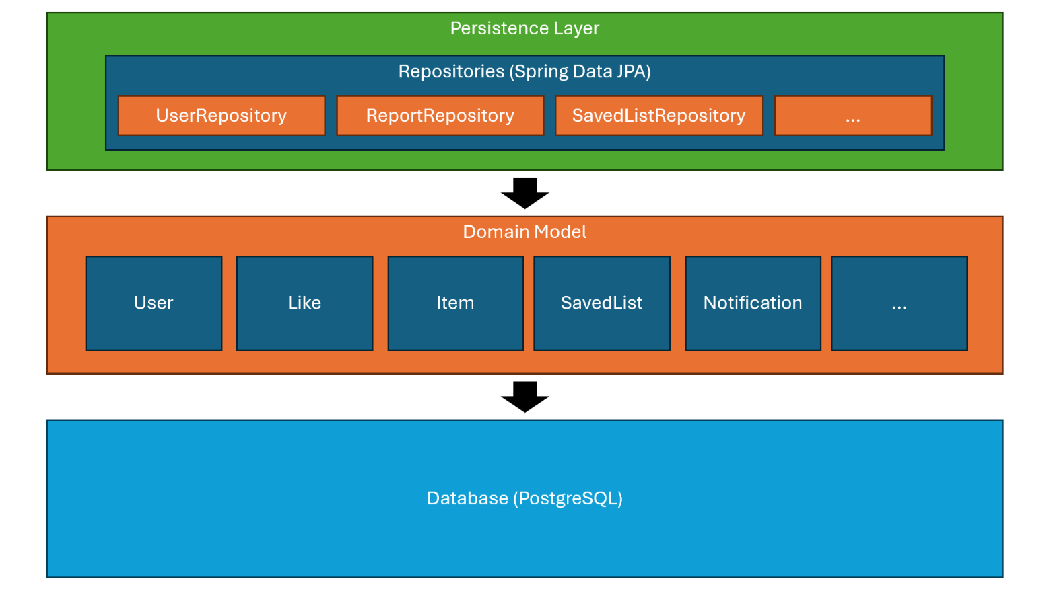
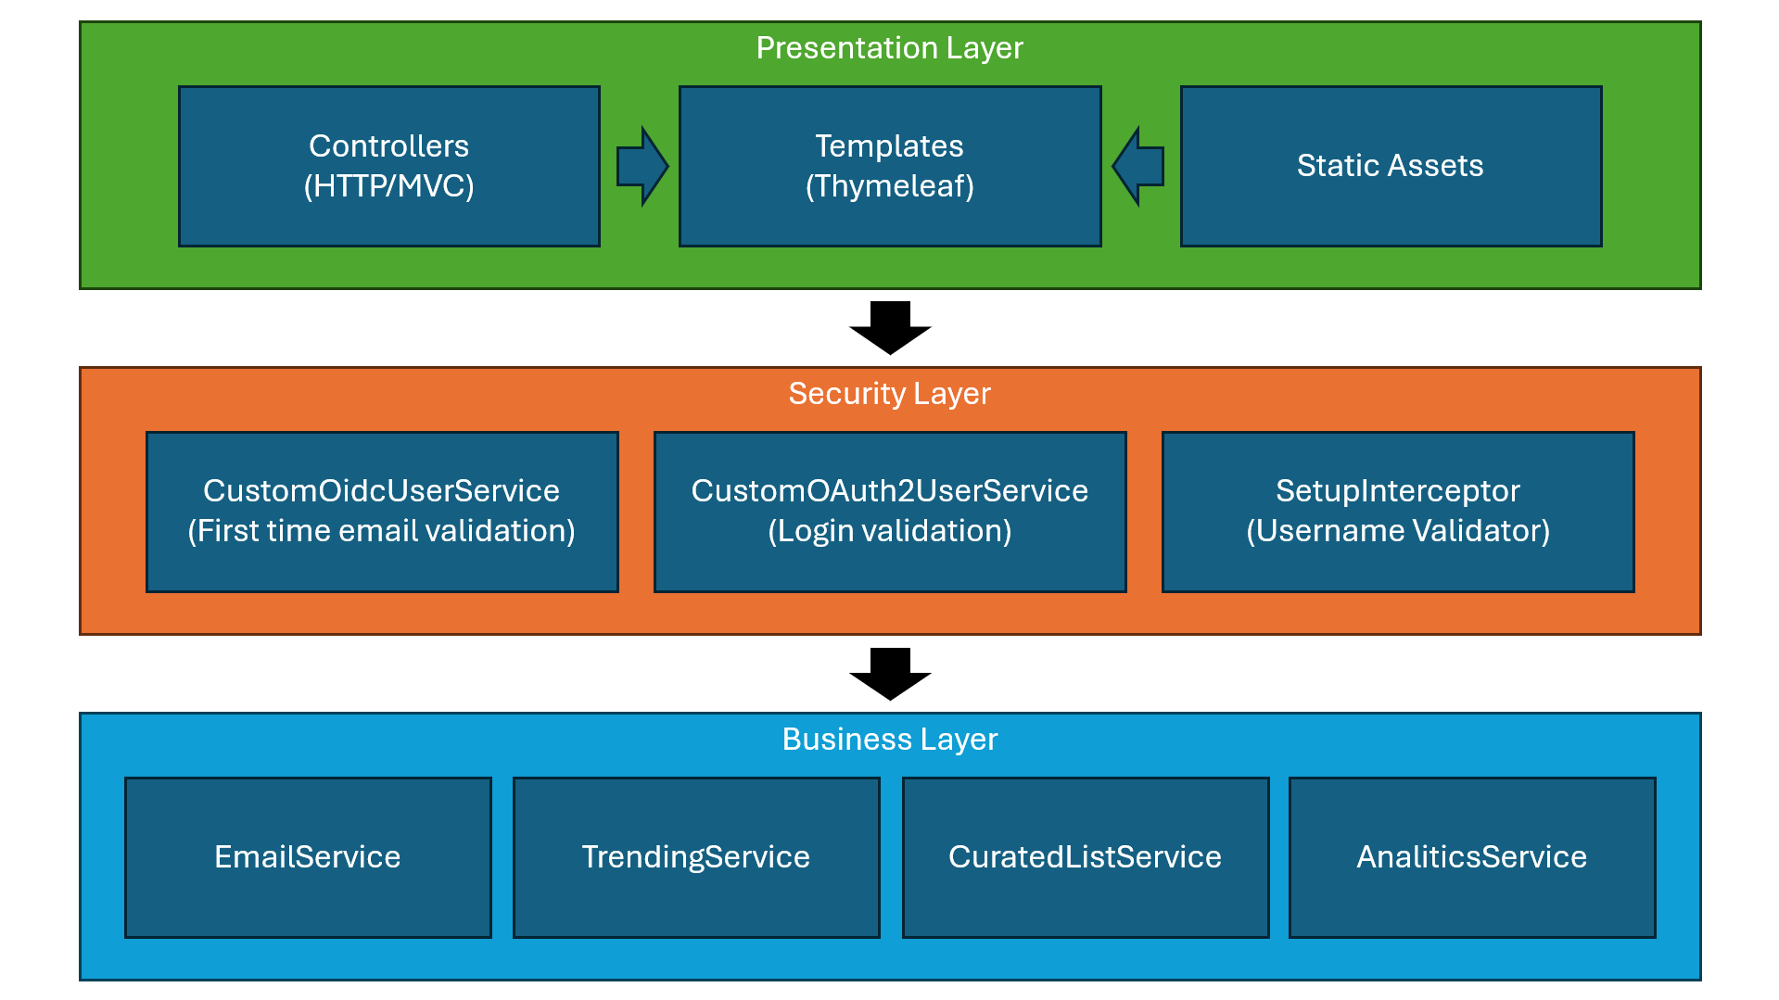
4.1.4. Architecture & Relationships
The following structural relationships exist between the artefacts described above.
Inheritance
- No custom entity inheritance hierarchy is used. All JPA entities extend Object directly and are annotated with @Entity. Role differentiation (STANDARD, VERIFIED, ADMIN) is modelled as an enum field on User rather than a class hierarchy, keeping the schema flat and the codebase simple.

Composition
- CuratedList embeds a Category reference (ManyToOne, mandatory). Removing a Category would require reassigning its lists; no cascade delete is configured on this relationship.
- Follow uses two foreign keys (follower_id, following_id) pointing to the users table, implementing a self-referential M:N relationship without a separate join table entity in the ORM layer.

Associations
Association | Cardinality | Optional? | Cascade
User → CuratedList (creates) | 1:N | Yes (user may have no lists) | CascadeType.ALL (delete user deletes lists)
CuratedList → Item | 1:N | Yes (list may be empty) | CascadeType.ALL (delete list deletes items)
CuratedList → Comment | 1:N | Yes | CascadeType.ALL
CuratedList → Like | 1:N | Yes | CascadeType.ALL
User → Comment (writes) | N:1 | No (comment must have author) | No cascade (delete user does not delete comments in MVP)
User → Like | N:1 | No | No cascade
User → Follow (as follower) | N:M via Follow entity | Yes | CascadeType.ALL on Follow
User → Notification | 1:N | Yes | CascadeType.ALL
User → Report (submits) | 1:N | Yes | No cascade
CuratedList → Category | N:1 | No (category is mandatory) | No cascade

4.1.5. Technical Requirements
Prerequisites:
- Docker Engine ≥ 24.x or Docker Desktop ≥ 4.x (includes Compose V2)
- Docker Compose V2 (docker compose command, not docker-compose)
- Git (to clone the repository)
- A .env file at the repository root populated from .env.example (see Environment Variables below)
- Optional for local development without Docker: JDK 17+, Apache Maven 3.9+

Build & Run:
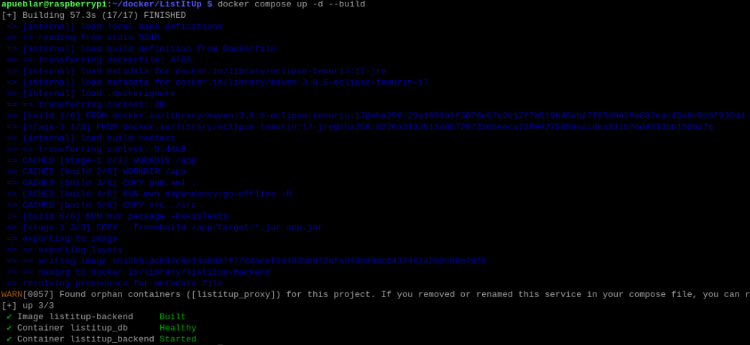
docker compose up -d –build

Run tests:
mvn test

Environment Variables:
.env — must be created from .env.example (never commit this file)
GOOGLE_CLIENT_ID=<your-google-client-id>
GOOGLE_CLIENT_SECRET=<your-google-client-secret>
GITHUB_CLIENT_ID=<your-github-client-id>
GITHUB_CLIENT_SECRET=<your-github-client-secret>
SMTP_PASSWORD=<app-password-for-smtp-account>

Ports:
Port | Service | Exposure | Notes
8080 | Spring Boot (backend) | Internal only | Internal container port; not exposed to host in production.
8082 | Spring Boot (backend) | Host-exposed | Mapped from container 8080. Used for local access and reverse-proxy forwarding.
5432 | PostgreSQL (db) | Internal only | Accessible only within the listitup_net Docker bridge network.
443 | HTTPS (reverse proxy) | Public | Production: SSL termination at host level; traffic forwarded to :8082.
80 | HTTP (redirect) | Public | Production: redirects to HTTPS.

4.1.6. MVP Feature Coverage
The table below maps each functional requirement to its primary implementation artefacts and records the completion status as of the S4 submission.
ID | Feature | Primary Artefacts | Status
FR1 | List creation and publishing | ListService, ListController, list-form.html | ✅ Complete
FR2 | Item management with drag-and-drop reorder | ItemService, ItemController, item-form.html, item-reorder.js | ✅ Complete
FR3 | Category-based discovery and keyword search | SearchService, SearchController, FeedController, search.html, feed.html | ✅ Complete
FR4 | Social interactions: follow, like, comment, save | SocialService, SocialController, ProfileController, list-detail.html, profile.html | ✅ Complete
FR5 | Content reporting and admin moderation panel | ReportService, AdminService, AdminController, admin/dashboard.html | ✅ Complete
FR6 | In-app and email notifications | NotificationService, EmailService, NotificationController, notifications.html, notifications.js | ✅ Complete
FR7 | Creator analytics dashboard (VERIFIED/ADMIN) | AnalyticsService, AnalyticsController, analytics.html | ✅ Complete
— | OAuth2 authentication (Google + GitHub) | SecurityConfig, CustomOAuth2UserService, OAuth2AuthenticationSuccessHandler | ✅ Complete
— | GDPR data export and account deletion | GdprController, UserService (/profile/export, /profile/delete) | ✅ Complete
— | Open Graph link metadata enrichment | OgService, og-preview.js (live preview in item form) | ✅ Complete

  - Tests
The documentation should cover the methods and test results of the specific system’s element both from the functional and non-functional point of view. The scope and the description should conform to the specification of the requirements (F2). You should include a description of at least one test of each type of requirement (e.g. business logic, user interface, data exchange, etc.).
    - Requirements Tests
In this section, you should differentiate the description of tests from manual and automated tests. You should include scripts or test case scenarios in the report.
      - Functional requirements tests
FR1 – Create a List
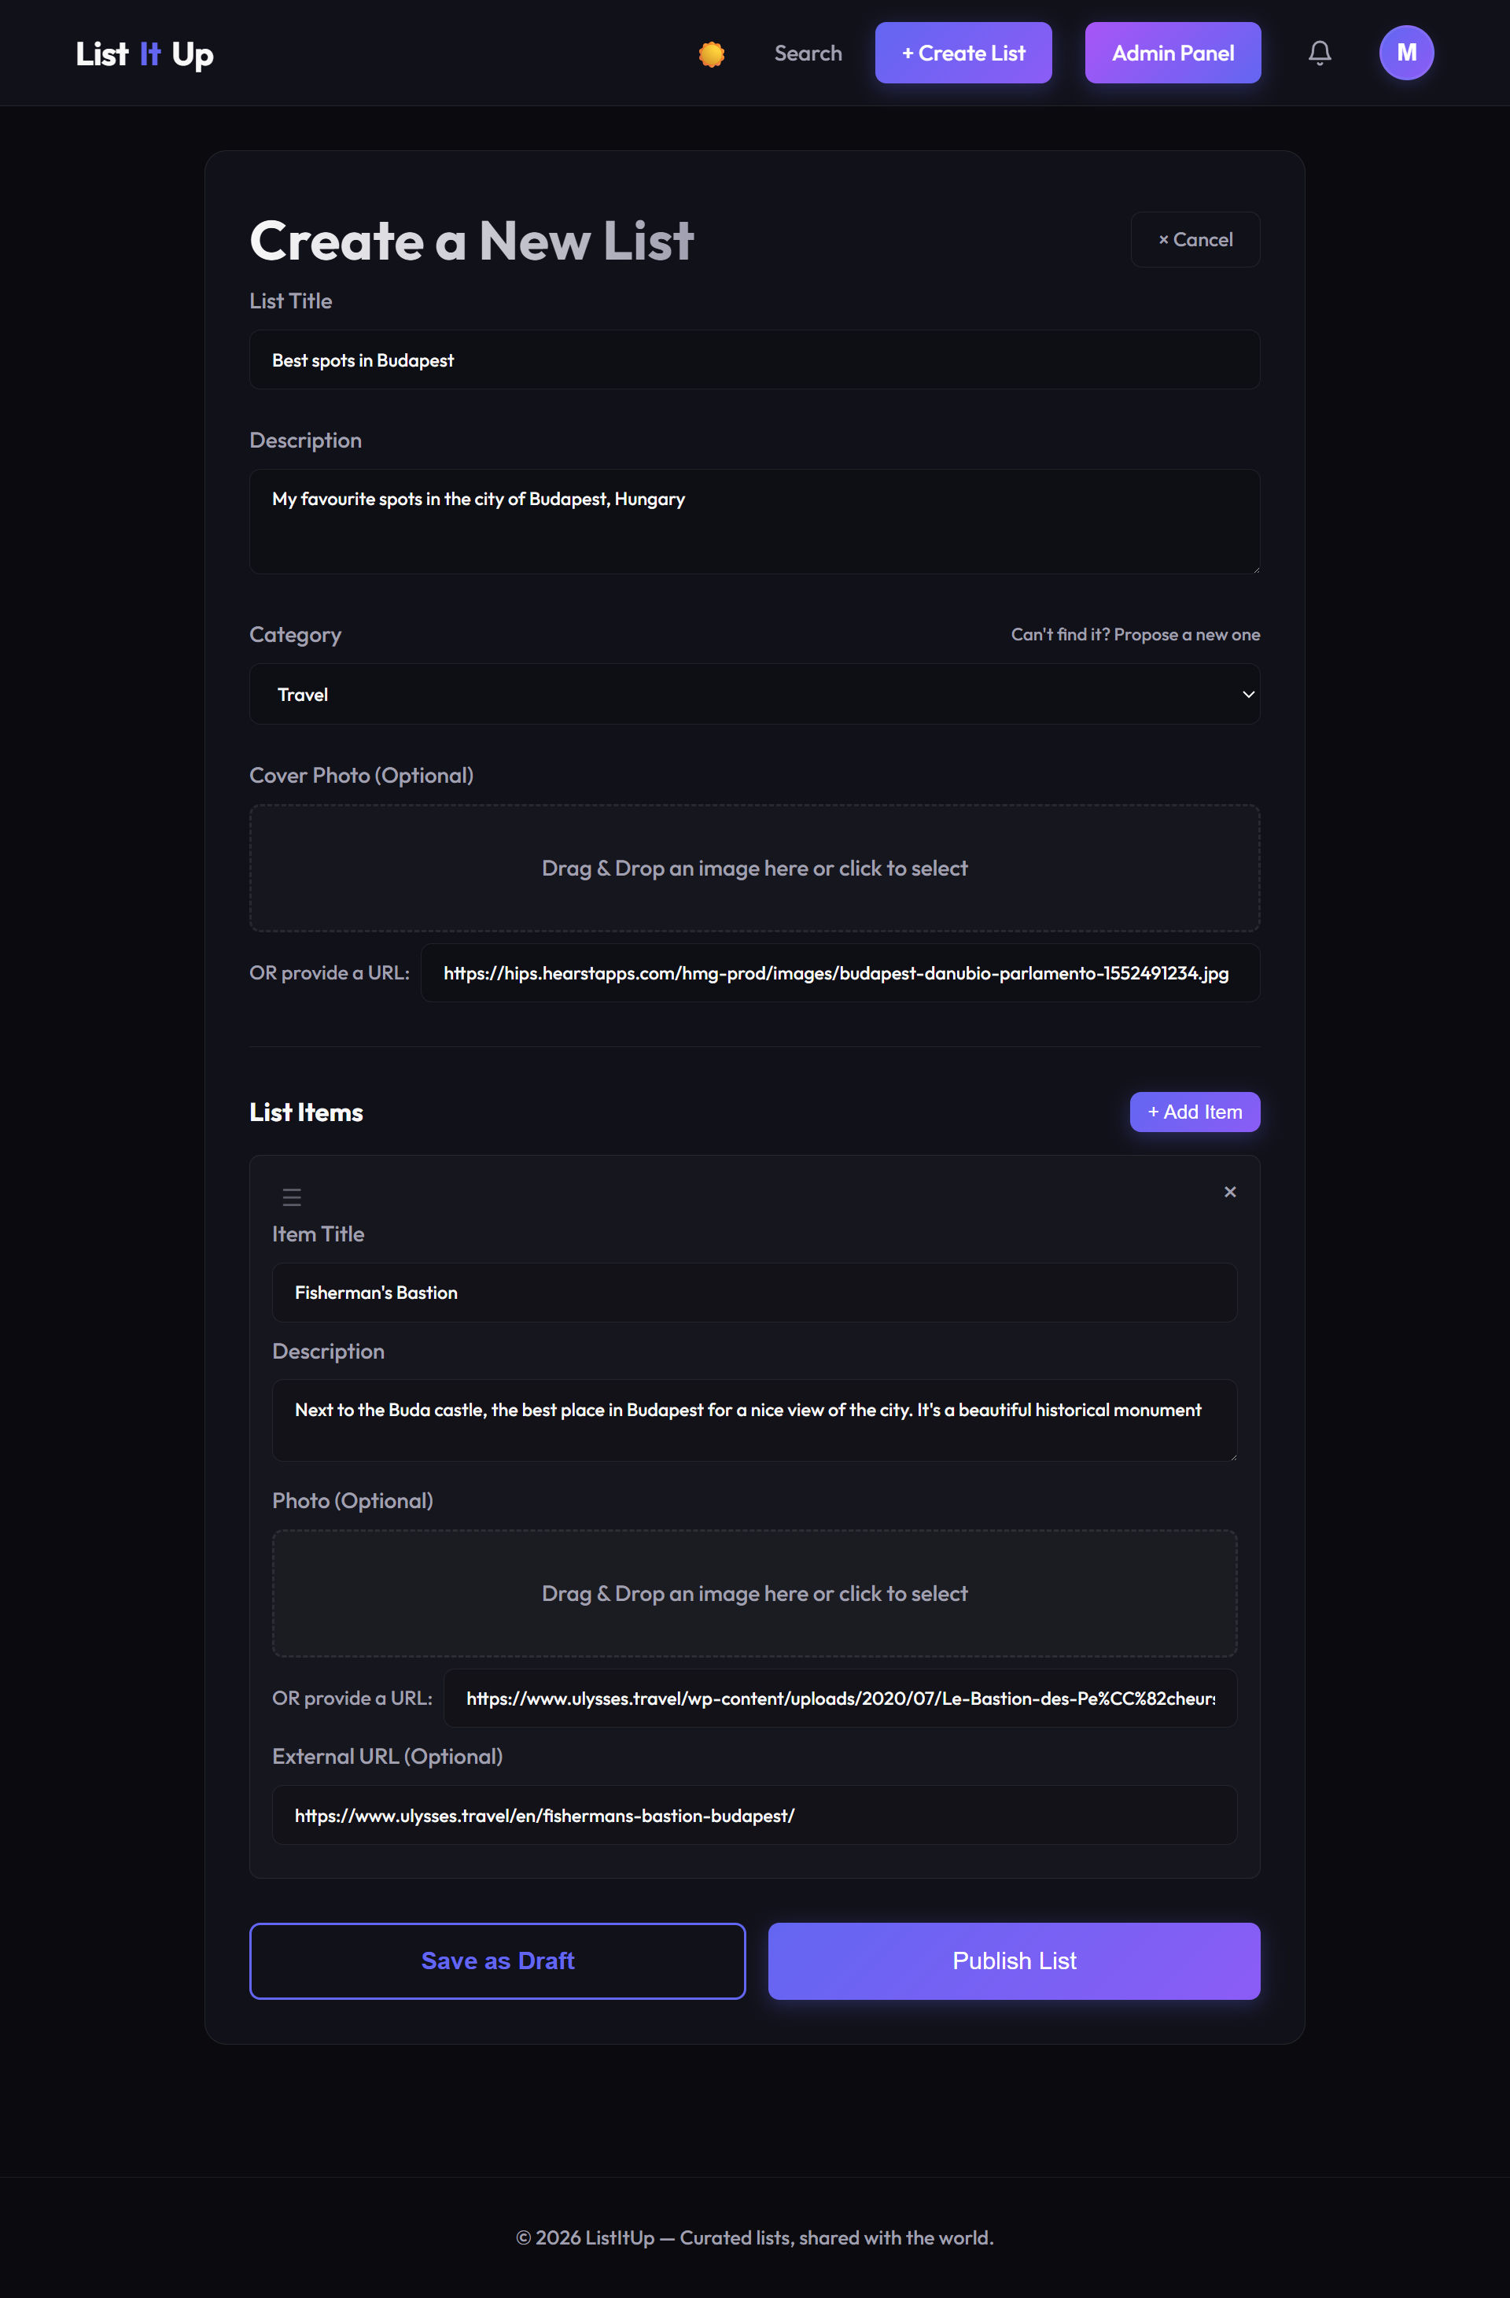
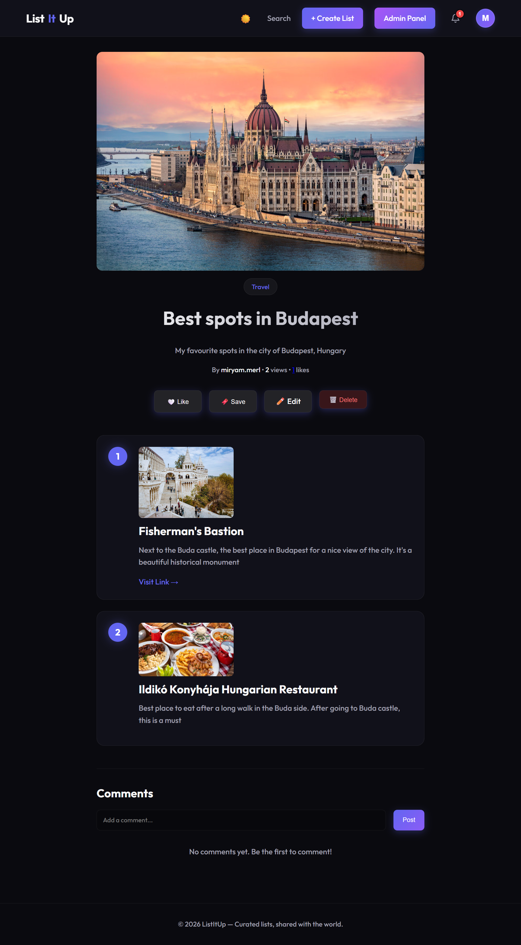

FR2 – Manage Items (Add, edit, reorder, delete)
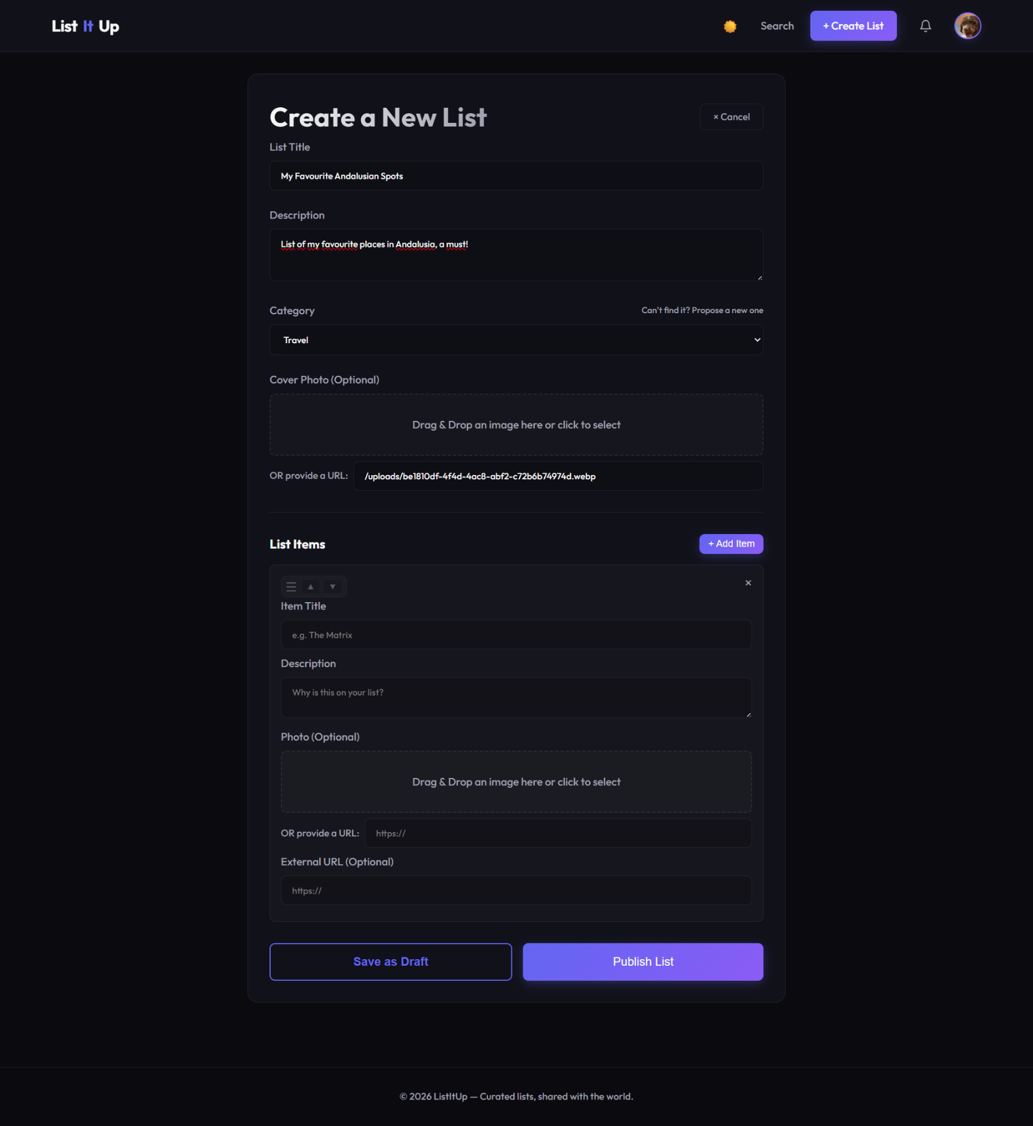
- Add

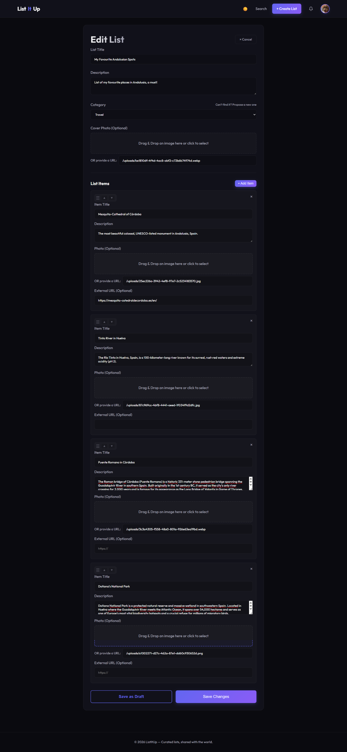
- Edit

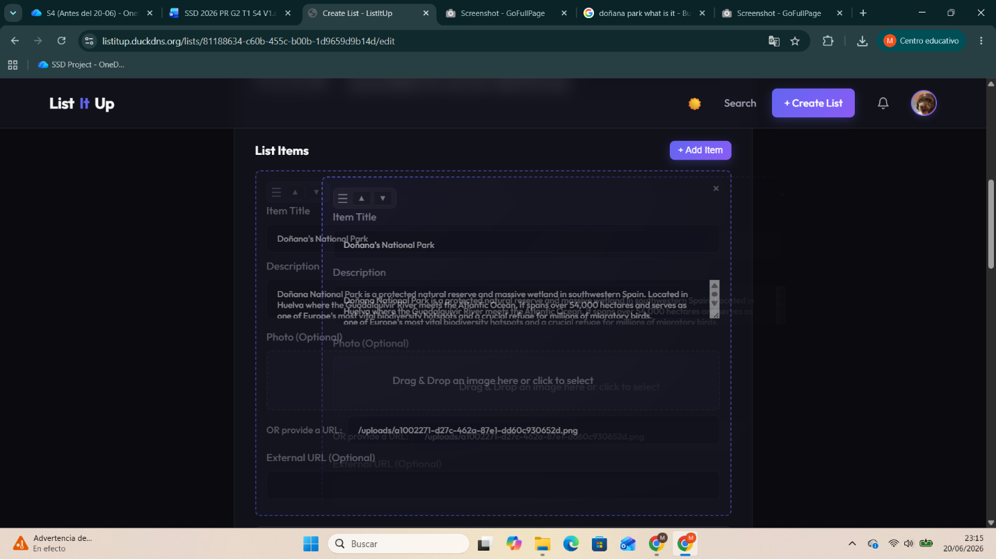
- Reorder

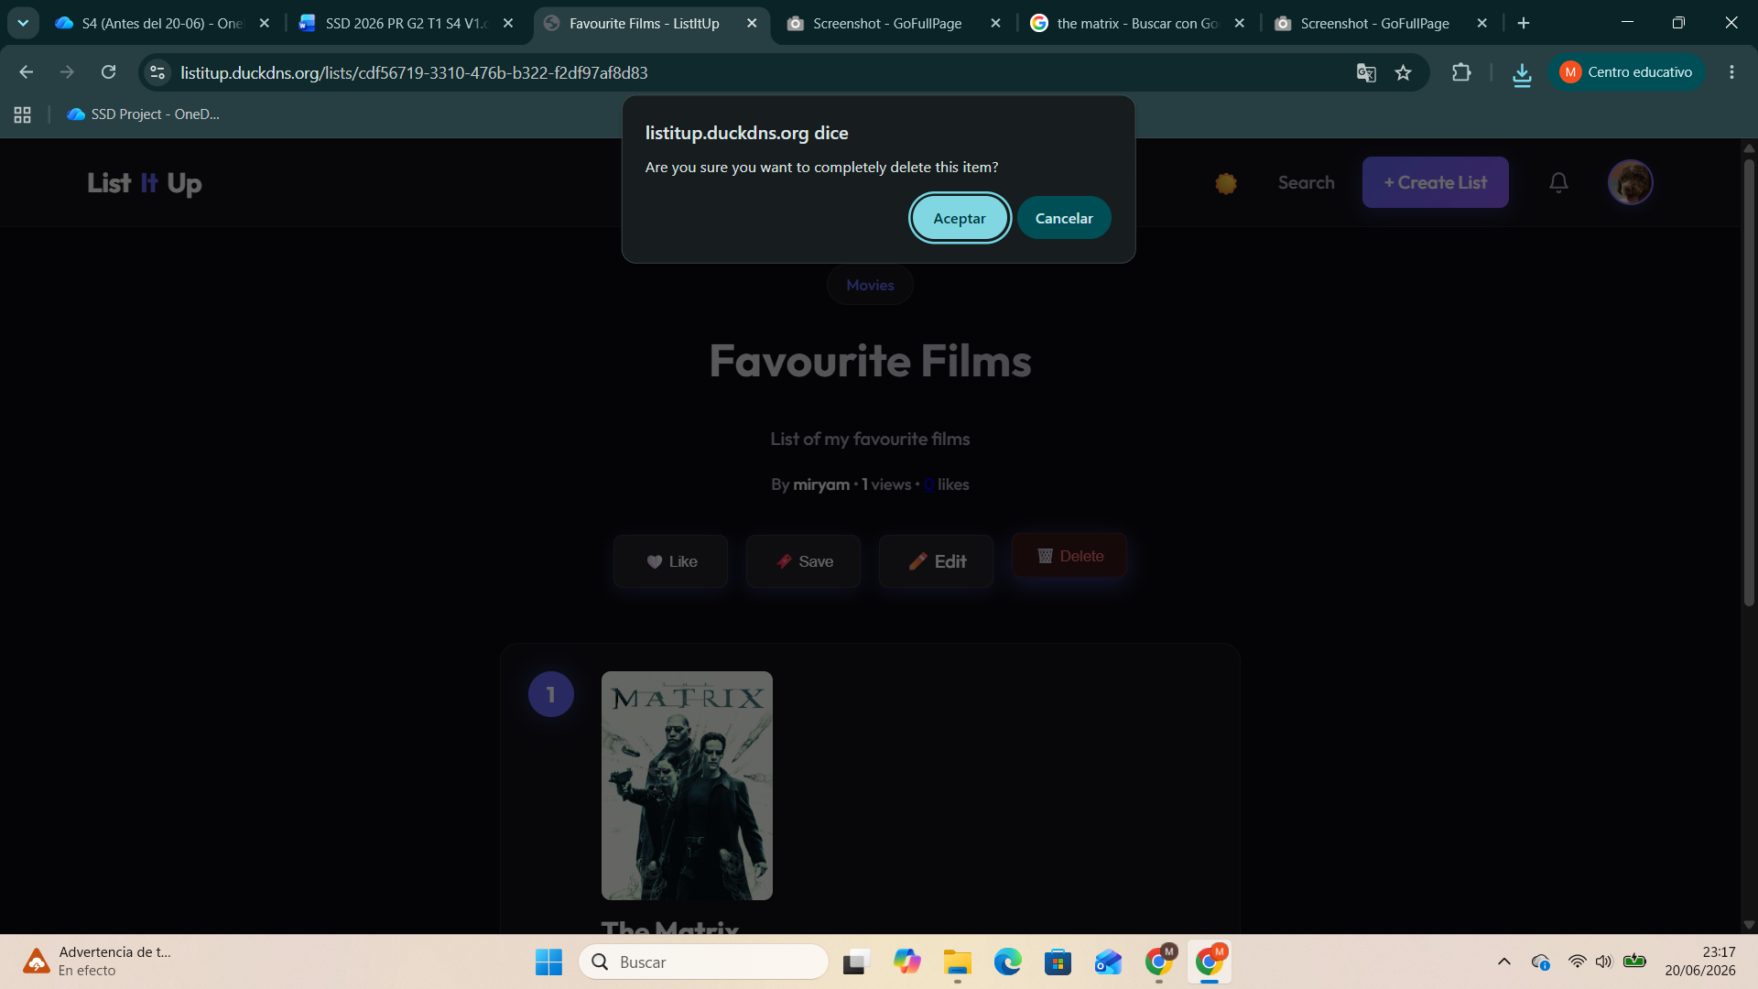
- Delete
FR3 – Discovery and Search
- By Category
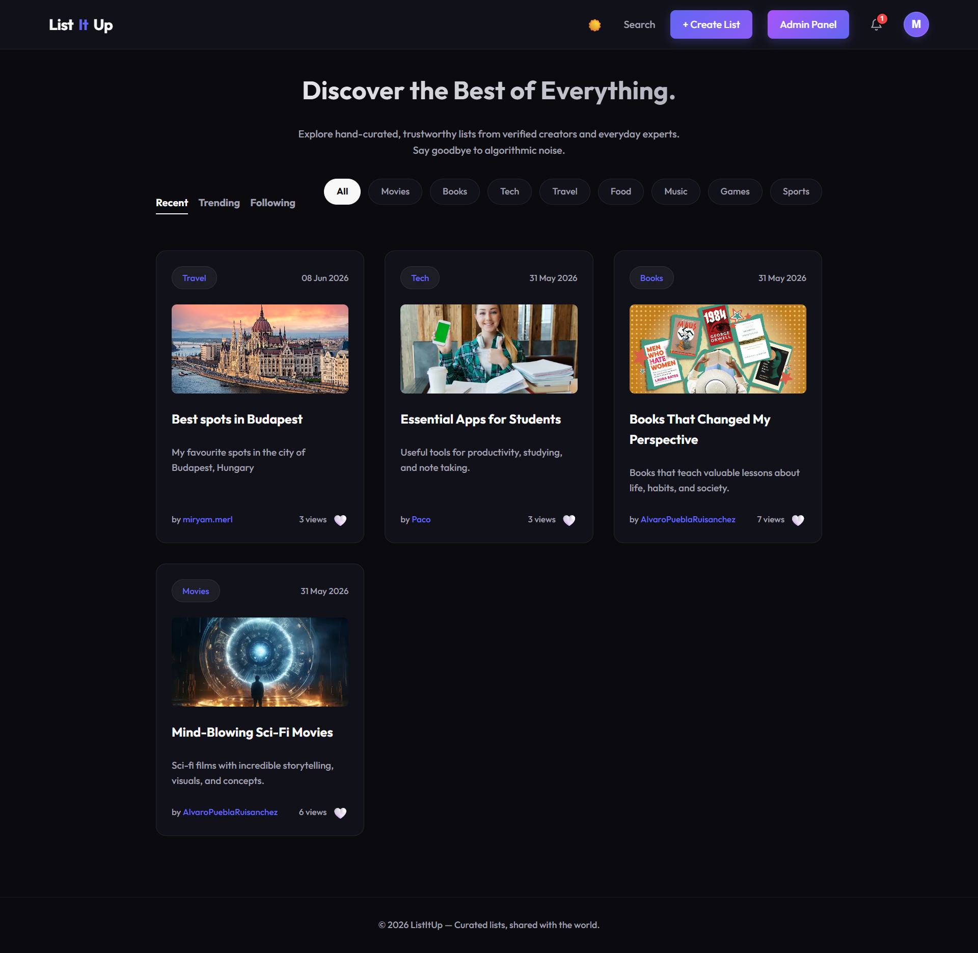

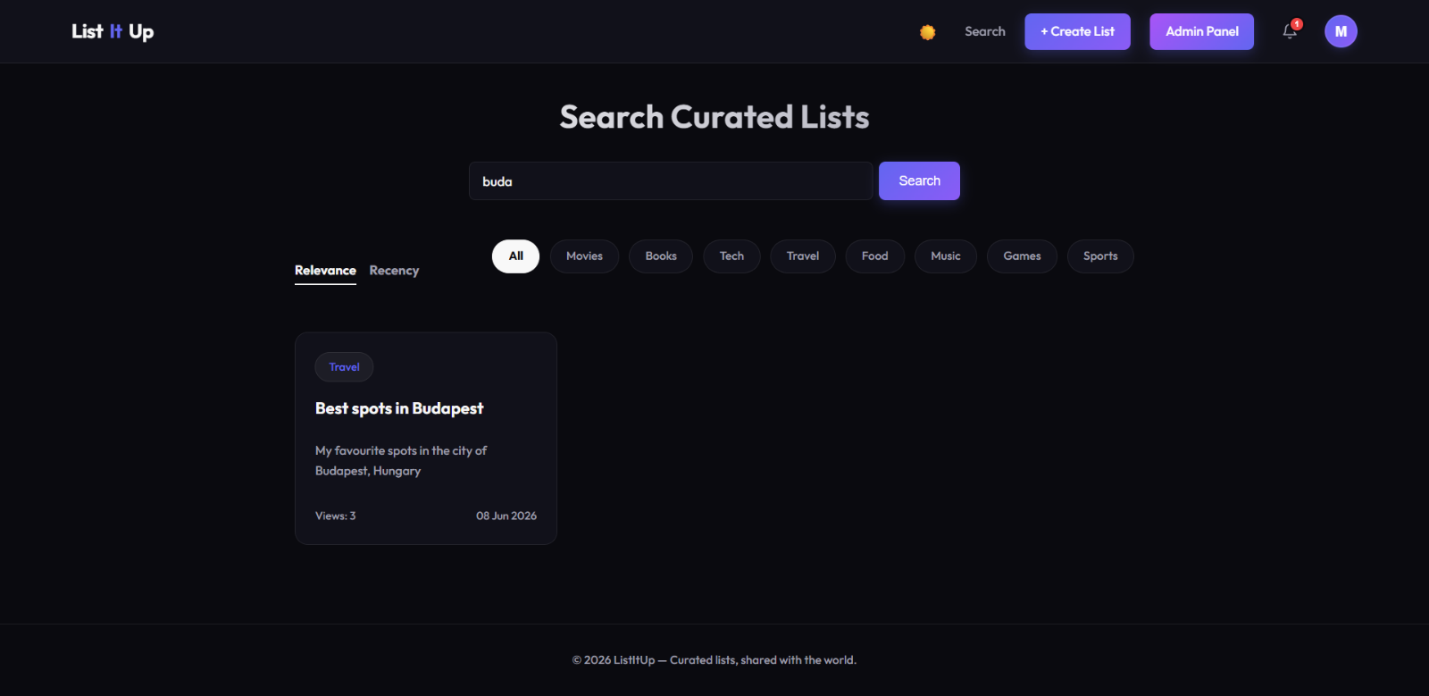
- By Keyword
- By Relevance
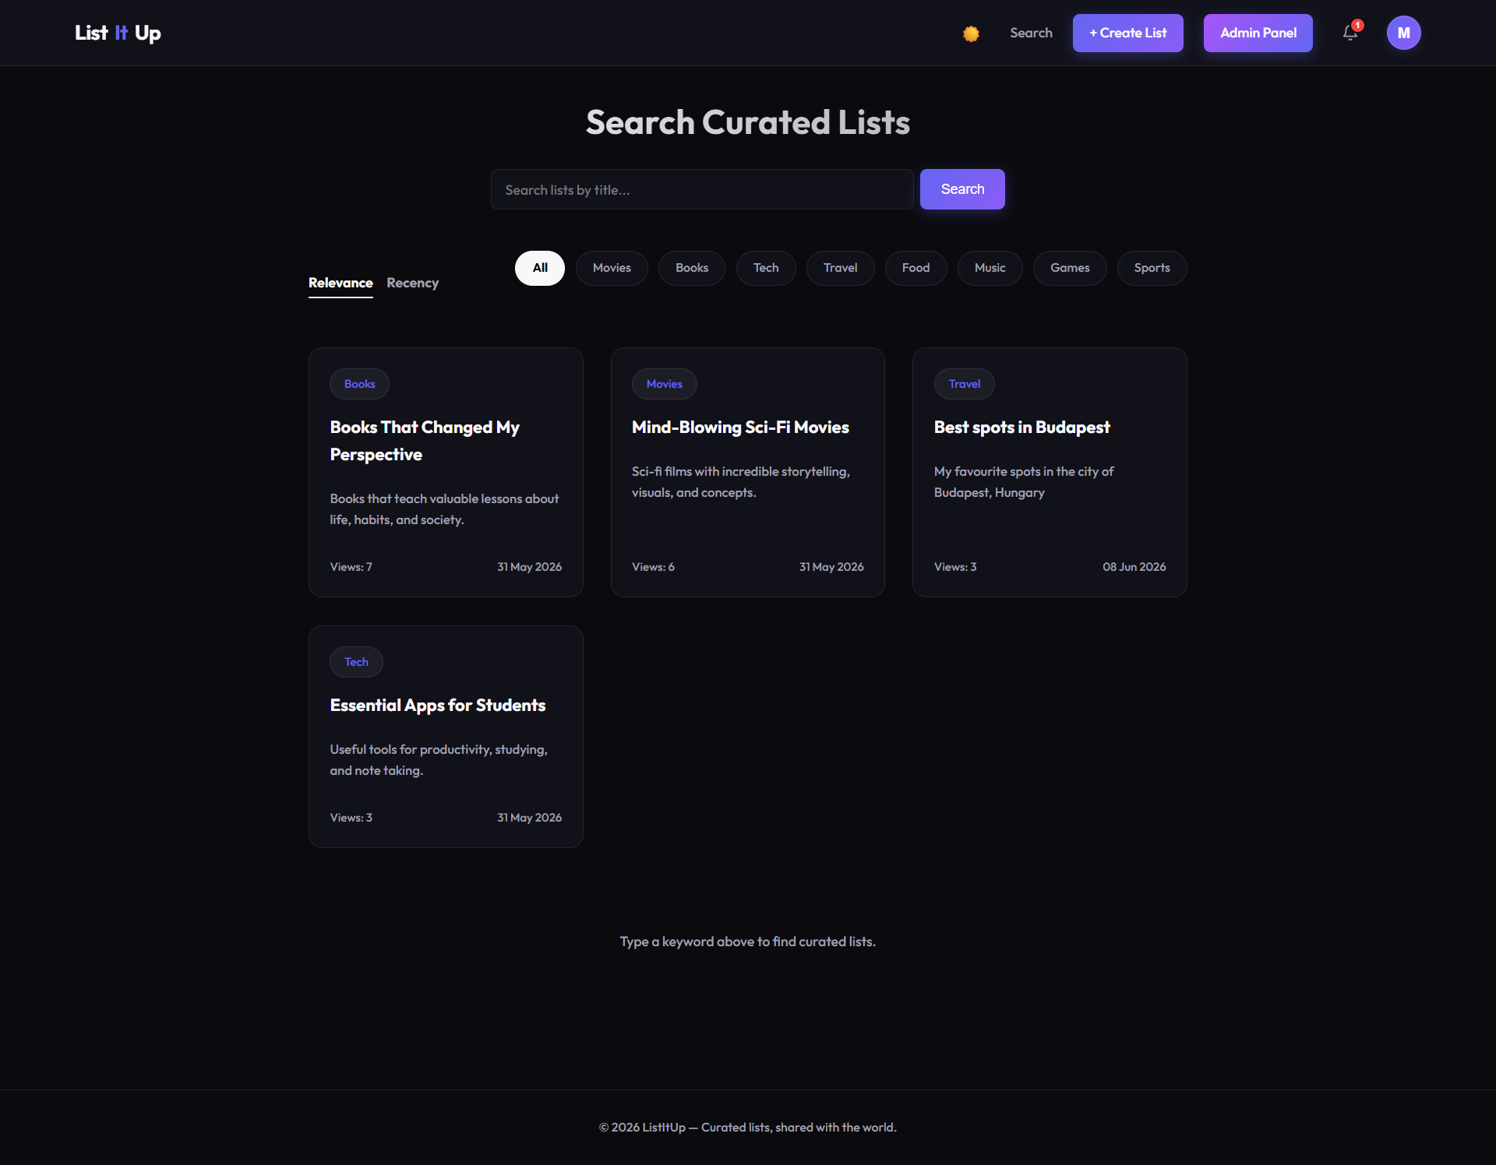
- By Recency
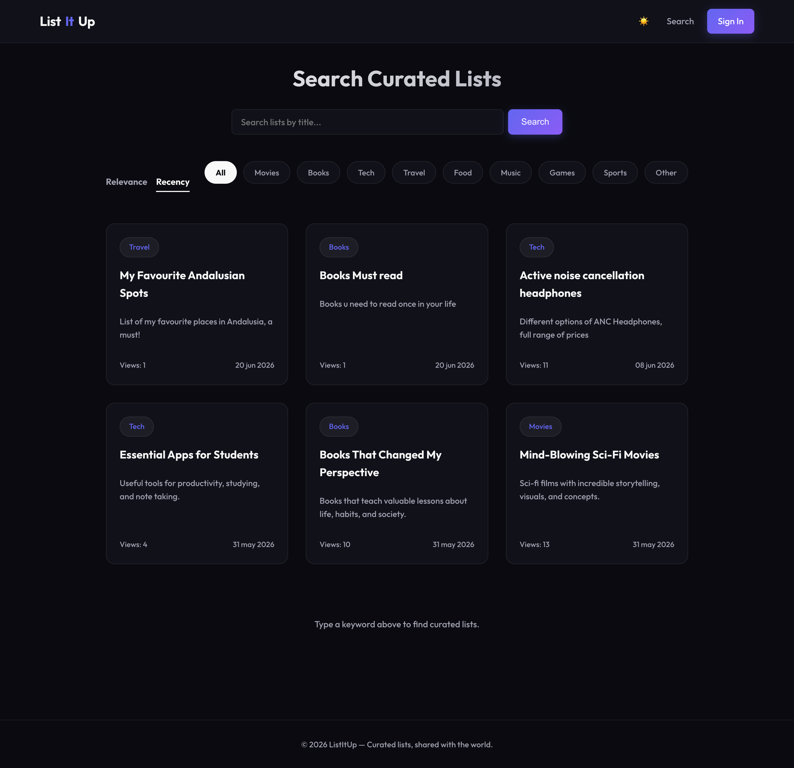
FR4 – Social Interactions
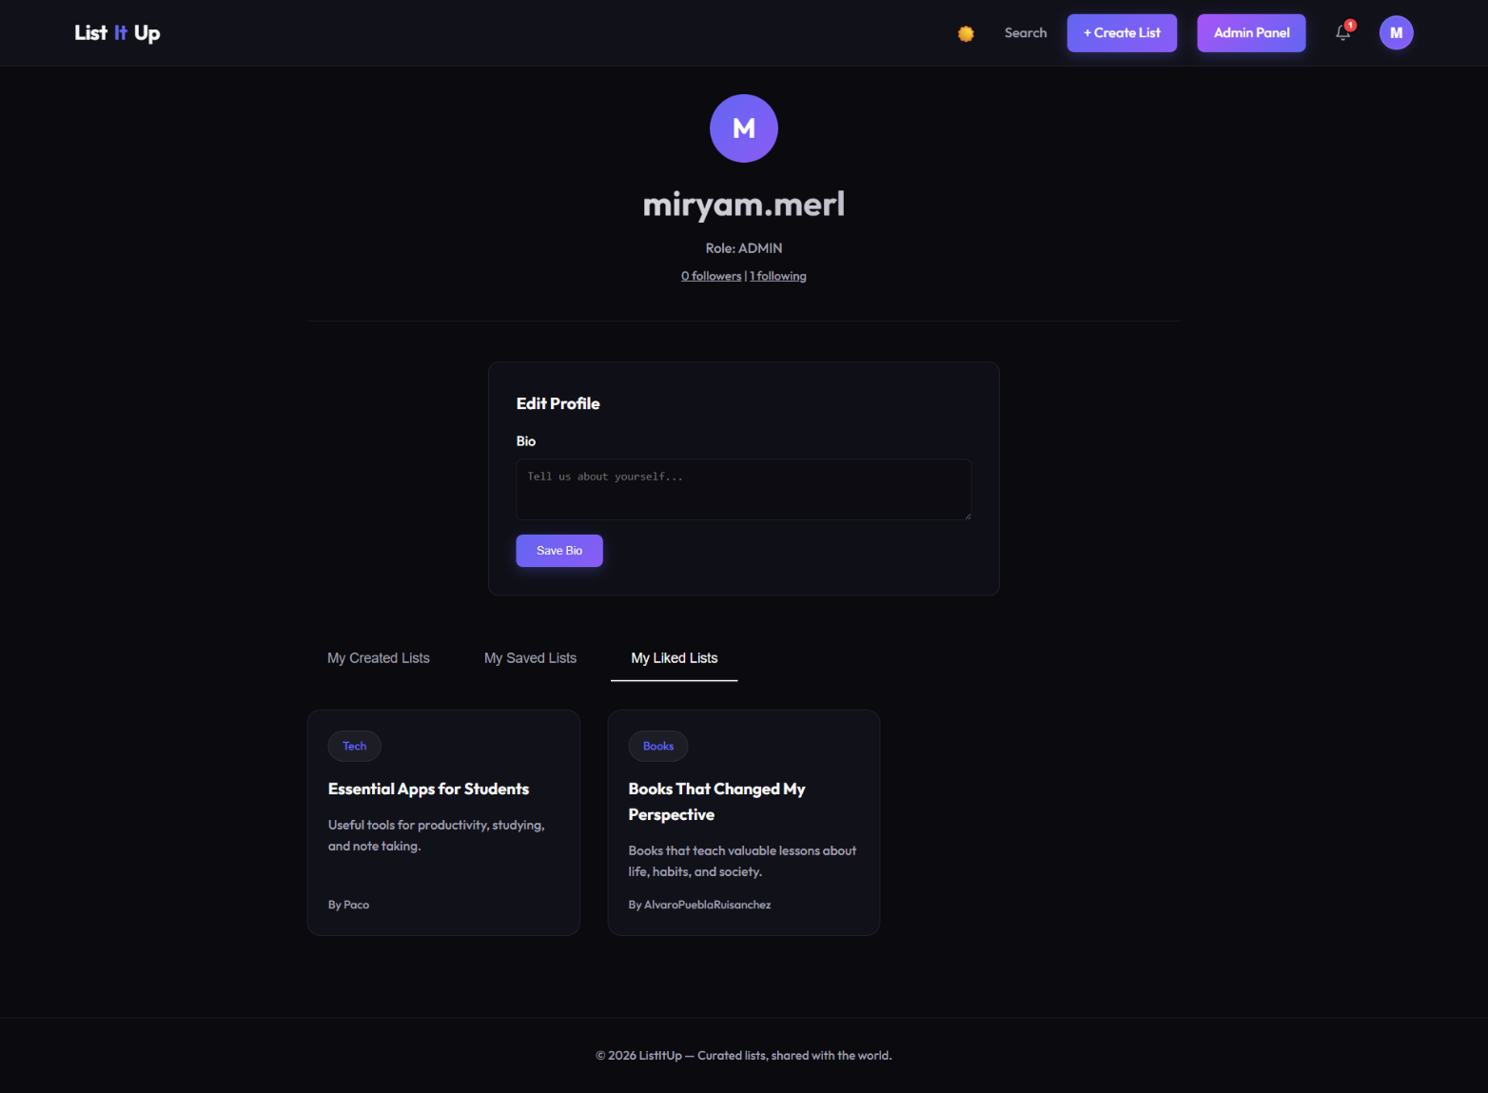


- Like Lists
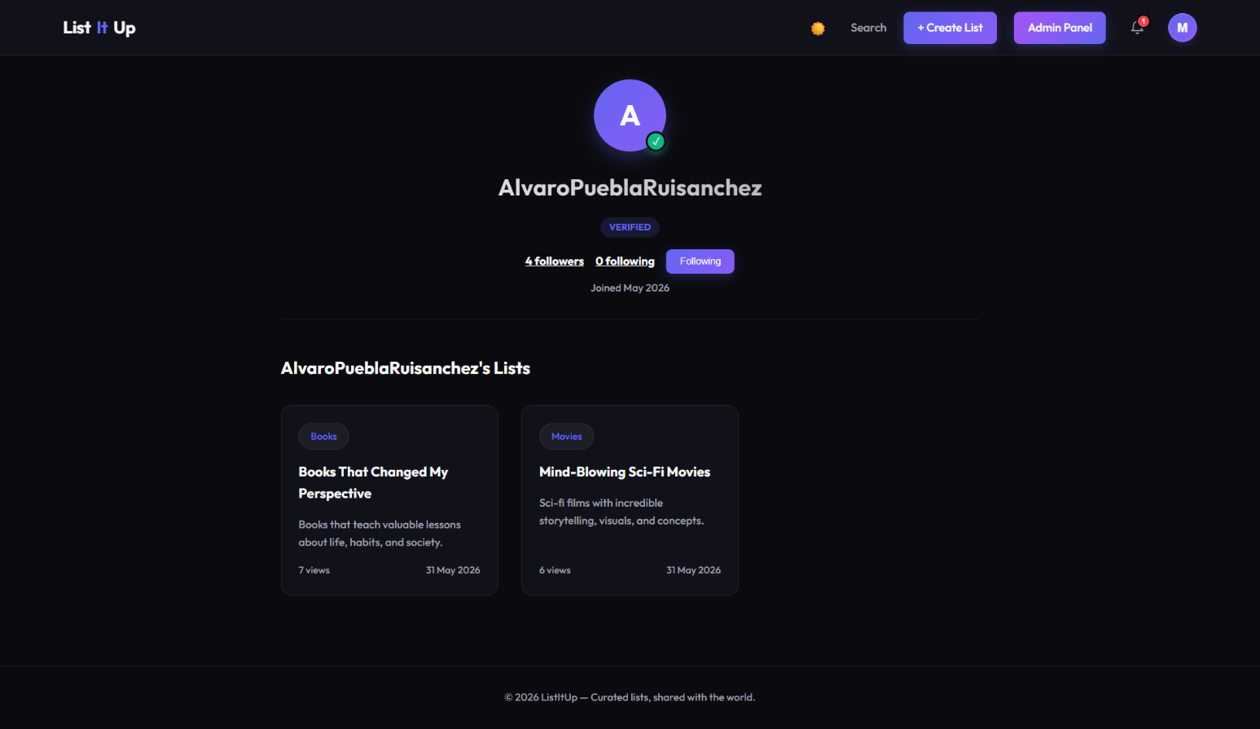
- Folow

- Post Comments
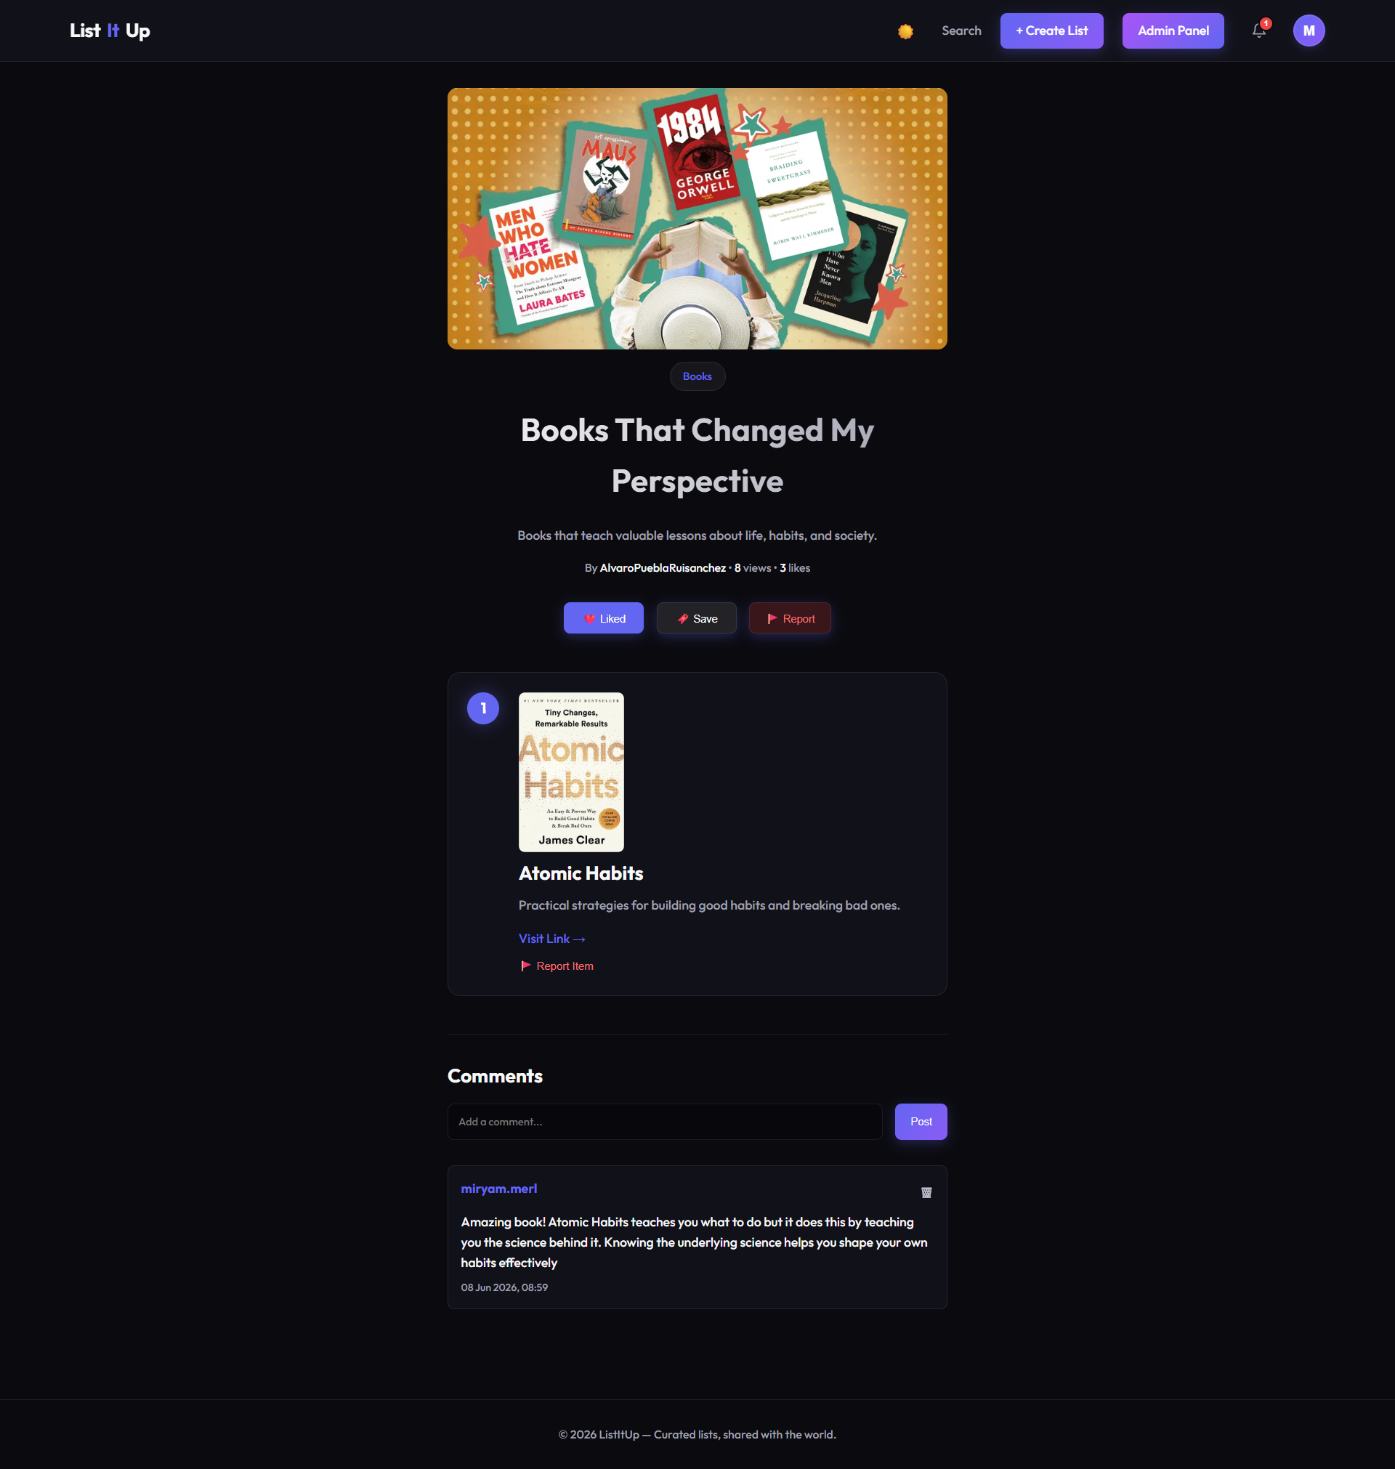
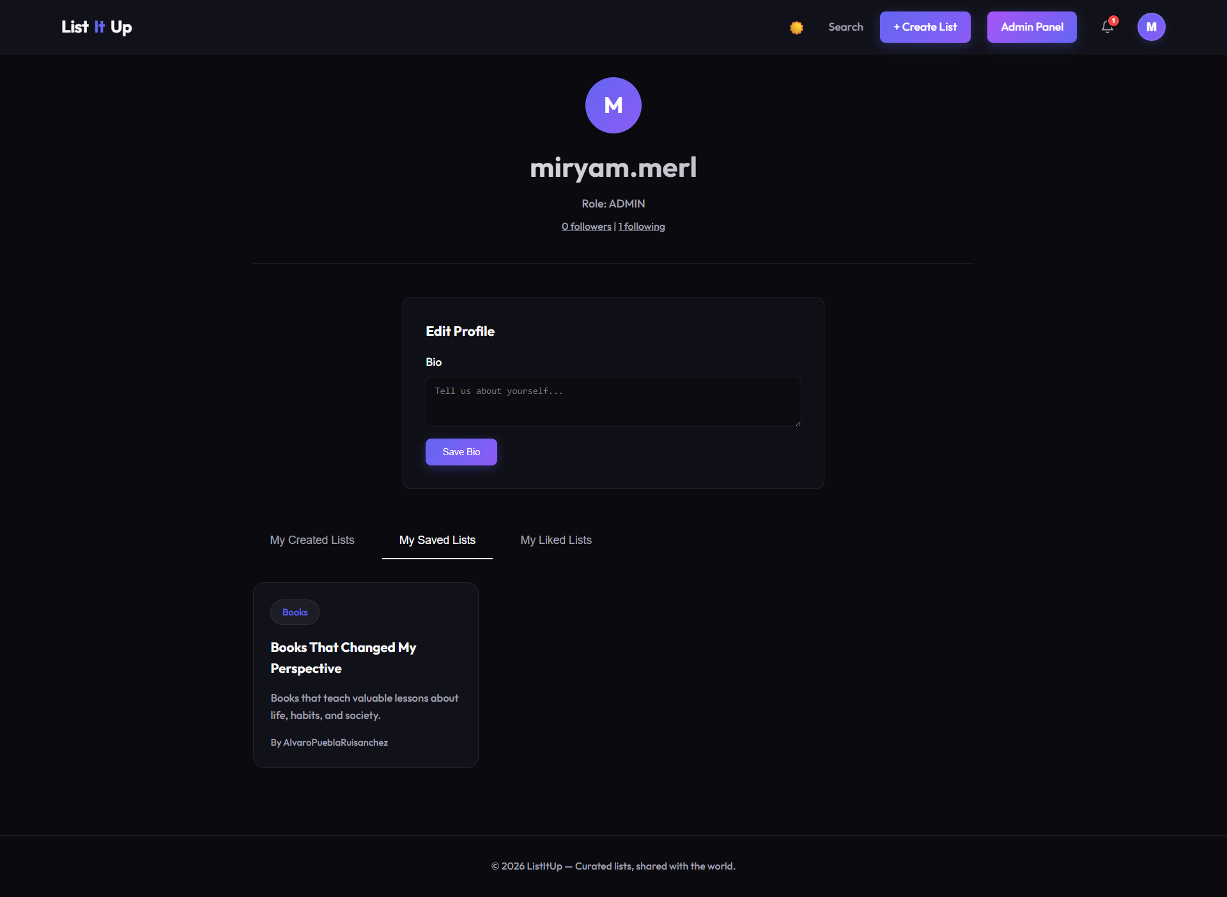
- Save Lists

FR5 – Reporting and Moderation
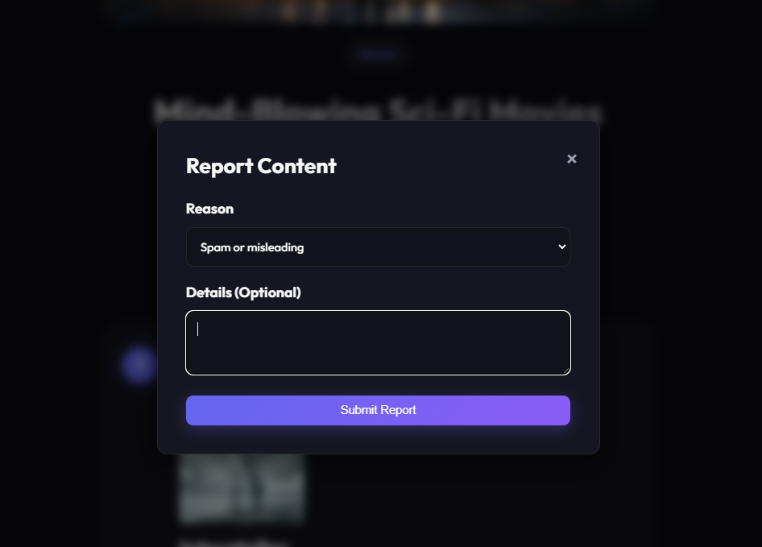
- Report List

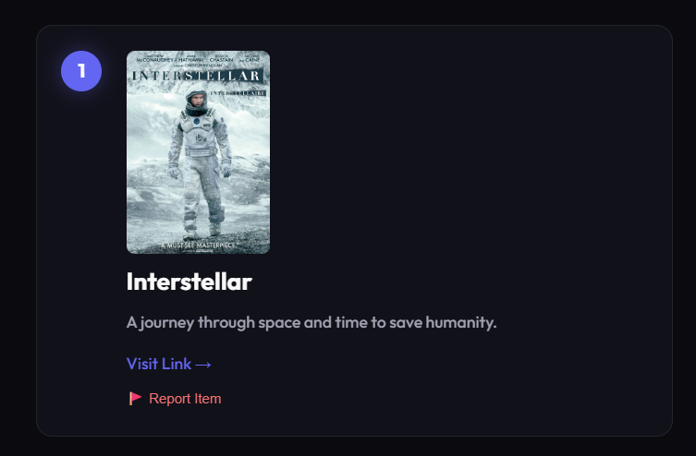
- Report Item

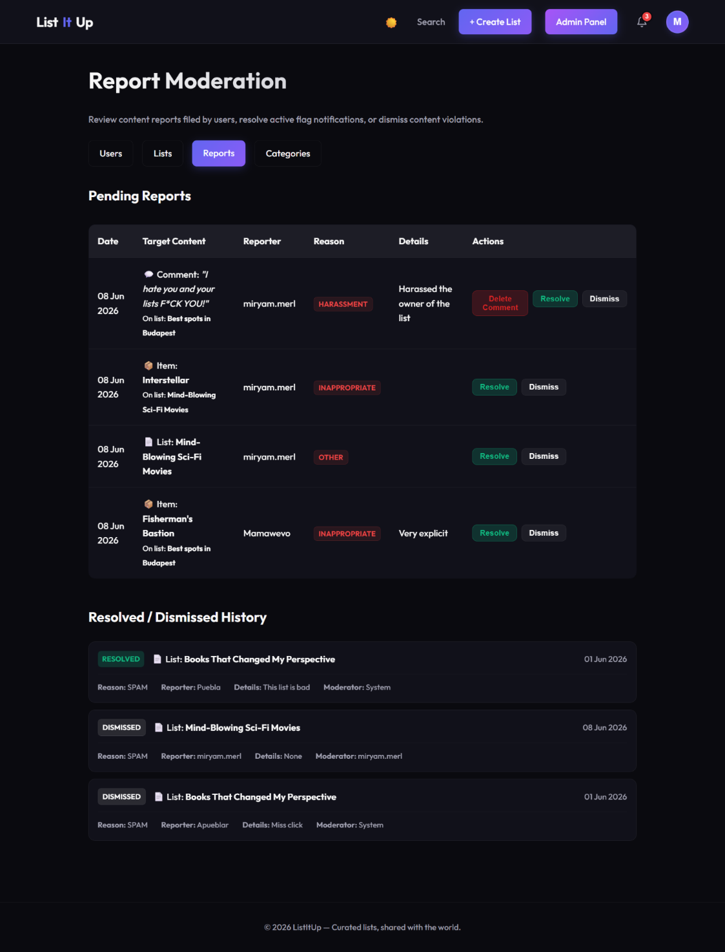
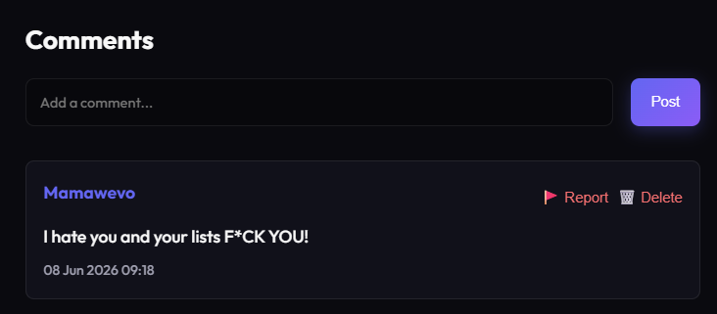
- Report Comment

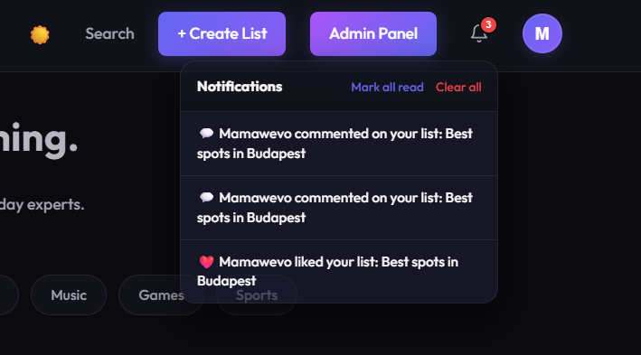
FR6 – Notifications
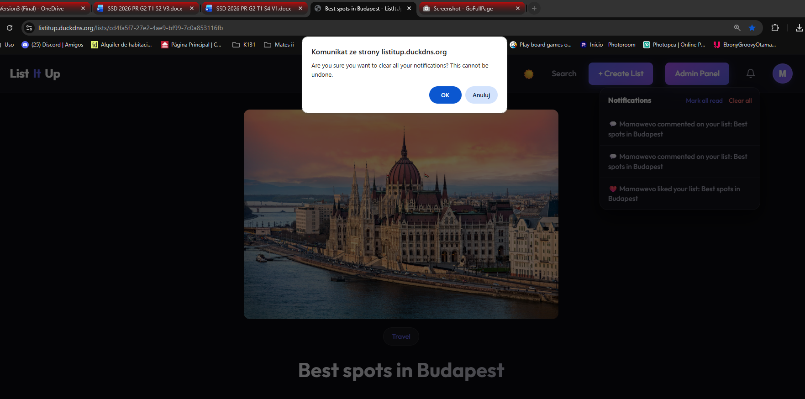

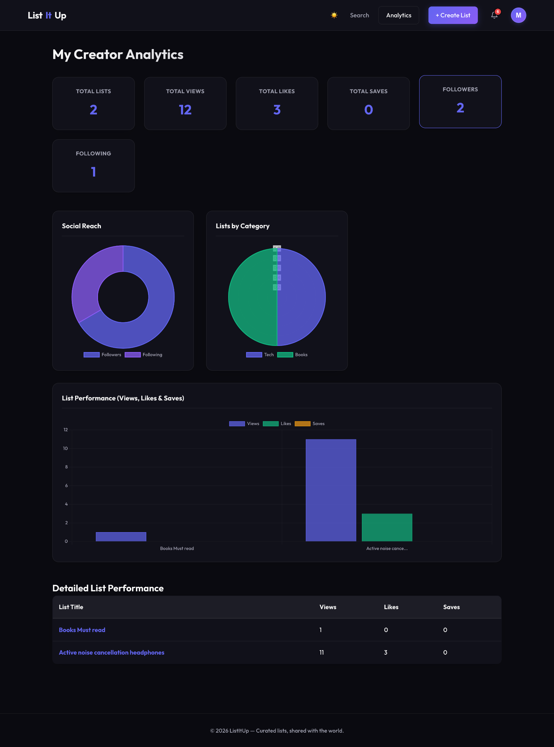
FR7 – Creator Analytics

      - Non-Functional requirements tests

NF1 – Page Load time < 3 sec
- Type: Performance / Efficiency.
- Description: Primary pages must fully render within 3 seconds on a stantard broadband connection, measured as Largest Contentful Paint (LCP) and Total Blocking Time (TBT).
- Verification Method: Google Chrome (Lighthouse).
- Test Results: The web successfully meets the requirement of fully rendering within 3 seconds. Across all three tested pages, the FCP consistently remained under 0.8 seconds, and the LCP never exceeded 1.4 seconds. Because the heaviest content on our core pages becomes fully visible in less than half the maximum allowed time, the application proves to be highly performant and responsive.
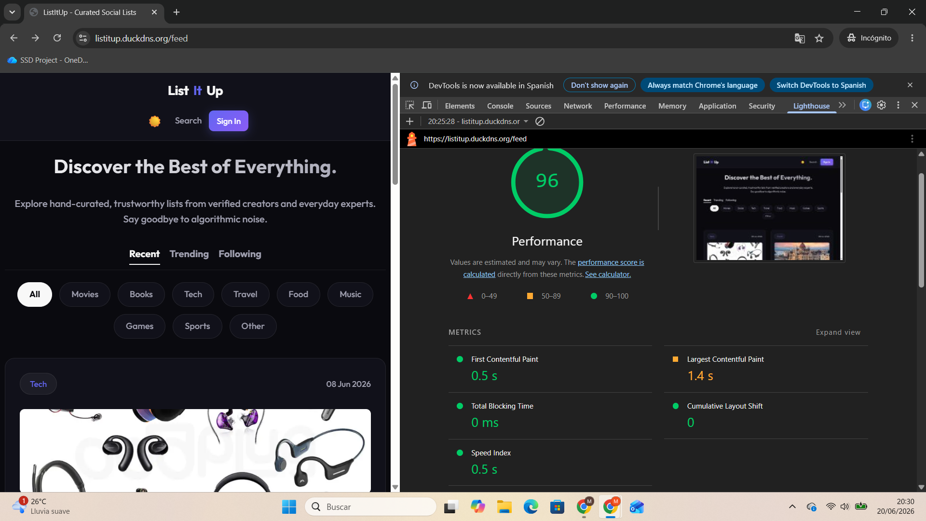
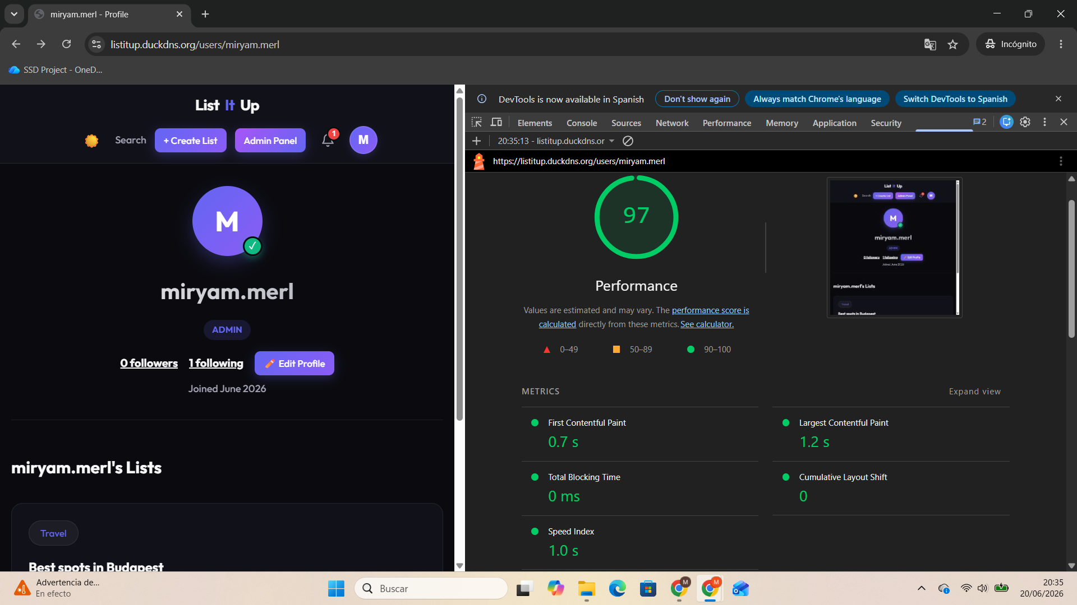
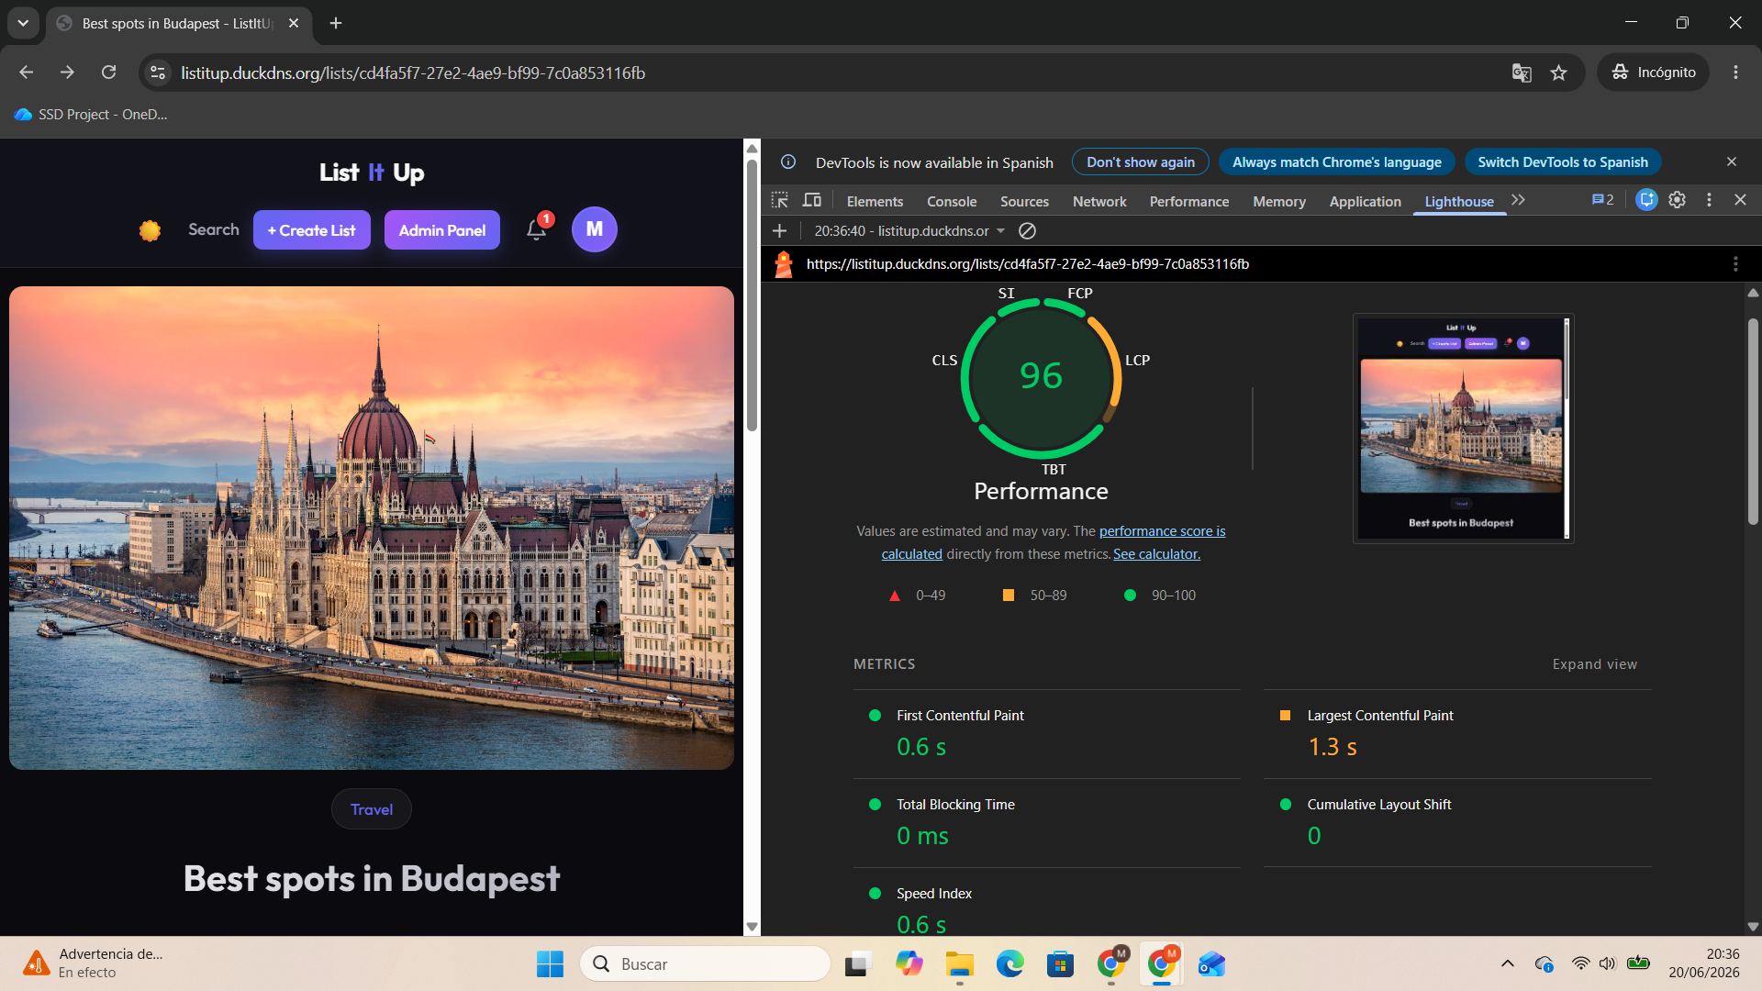
NF2 – System Uptime >= 99.5%
- Type: Reliability / Availability.
- Description: The platform must maintain at least 99.5% uptime throughout the pilot period.
- Verification Method: UptimeRobot.
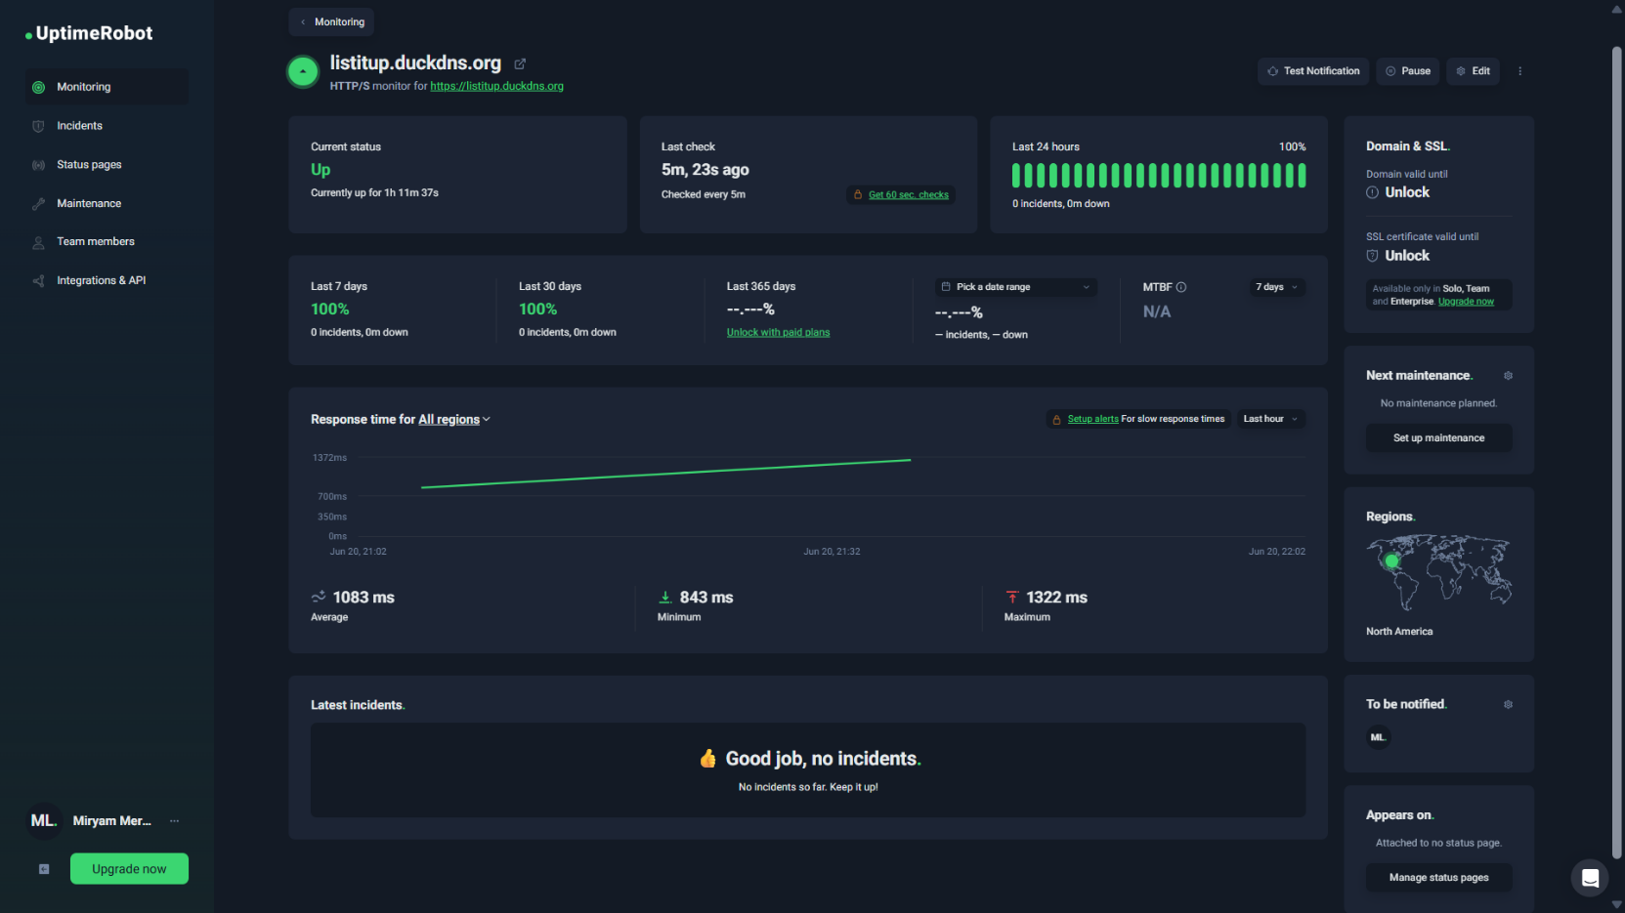
- Test Results: To verify the system's reliability, we configured an UptimeRobot to continuously track the production environment at https://listitup.duckdns.org. The monitoring results confirm that the platform successfully remained stable, maintaining an uptime of 100%, which exceeds the required 99.5% threshold established for the pilot period.

NF3 – HTTPS Encryption (>=TLS 1.2)
- Type: Security
- Description: All client-server communication must be encrypted using TLS 1.2 or higher. No sensitive data may be transmitted over plain HTTP.
- Verification Method: Browser Developer Tools and SSL Labs security test.
- Test Results: To verify that all client-server communication is securely encrypted, a two-part validation was performed. First, inspection via the browser's Developer Tools (Network tab) confirmed that all active requests are routed exclusively through HTTPS. Second, an external security audit was conducted using Qualys SSL Labs on the production domain (listitup.duckdns.org). The server achieved an overall rating of "A", confirming that it correctly enforces TLS 1.2 or higher and meets modern cryptographic standards.

HTTPs header:
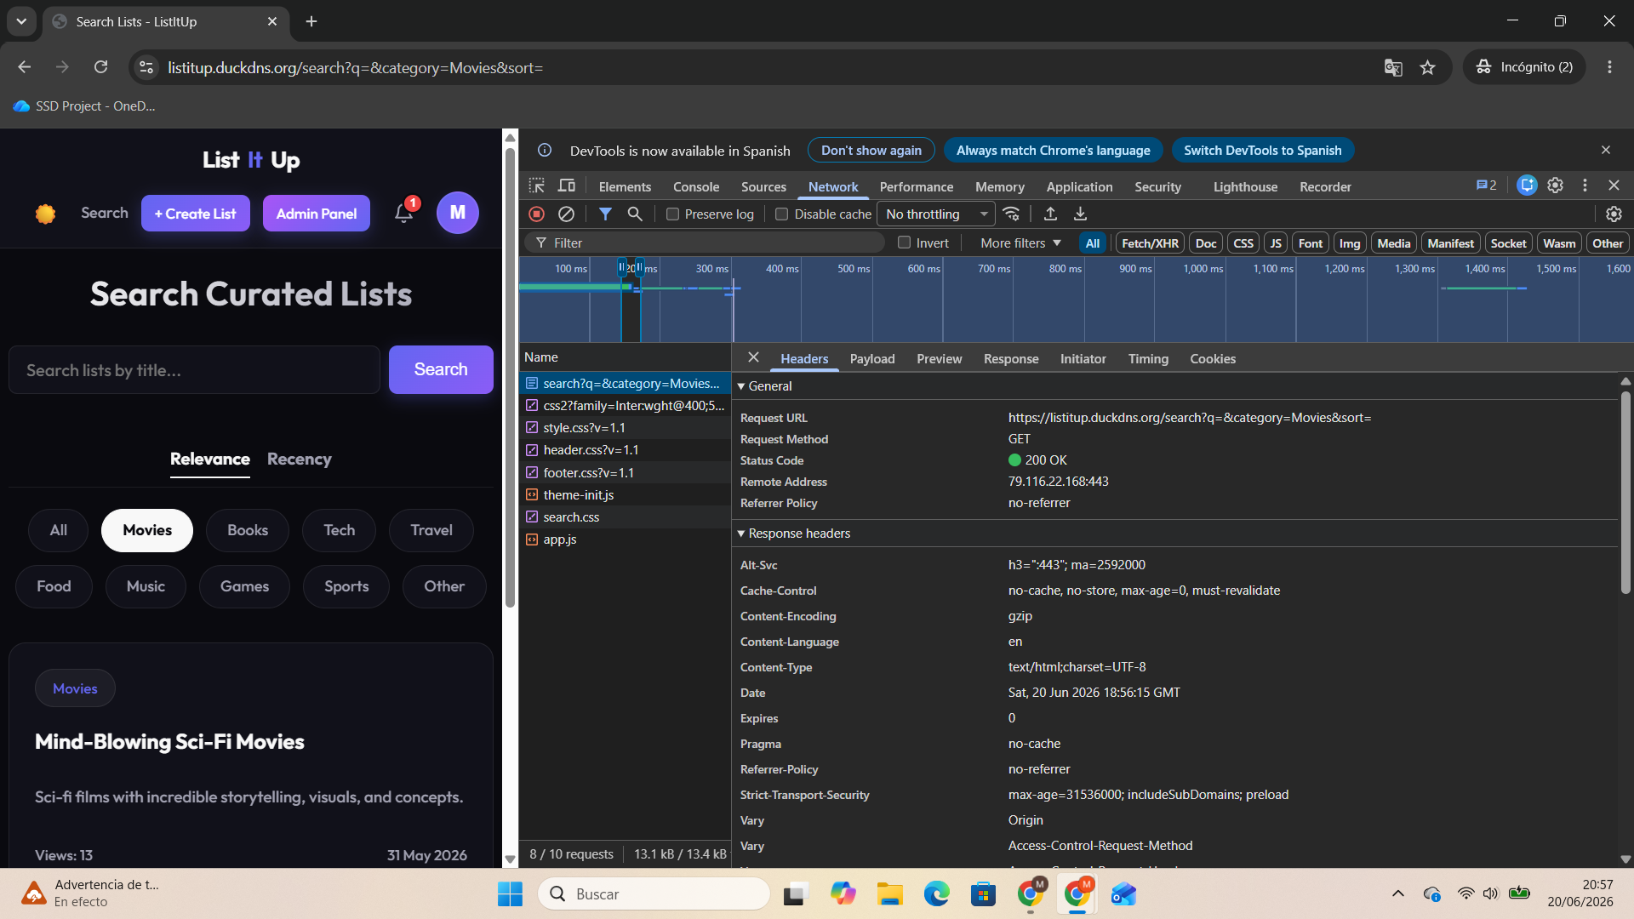

SSL Report:
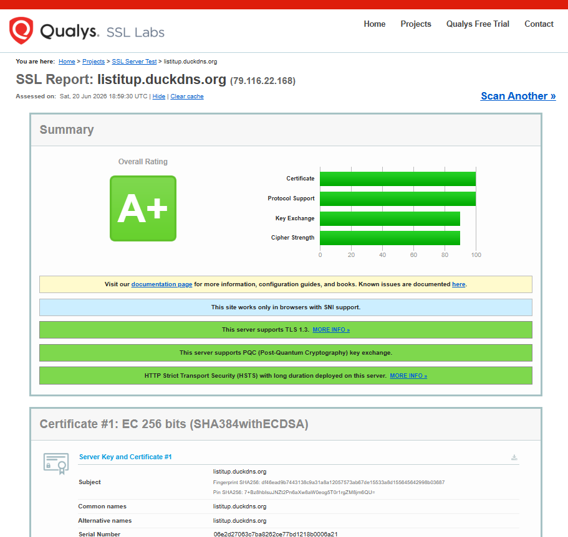

NF4 – GDPR / Legal Compliance
- Type: Legal / Privacy
- Description: The platform must comply with GDPR/RODO: users must be able to access, rectify, and erase their personal data. A cookie-consent banner must be displayed on first visit before any non-essential cookies are set.
- Verification Method: Cookie consent showing on incognito browsing session, manual testing of the profile management interface and account deletion workflow.
- Test Results: To verify compliance with GDPR/RODO regulations, a manual verification of user data privacy rights was conducted according to the specified criteria:
  - Cookie Consent: An incognito browsing session confirmed that a cookie-consent banner is prominently displayed upon the first visit, ensuring no non-essential cookies are set prior to user consent.
  - Data Access and Rectification: Manual testing of the profile management interface confirmed that users can successfully access and update their personal information at any time.
  - Right to Erasure (Deletion): The account deletion workflow was manually executed. Subsequent login attempts asked for a new username.

Cookie Consent:
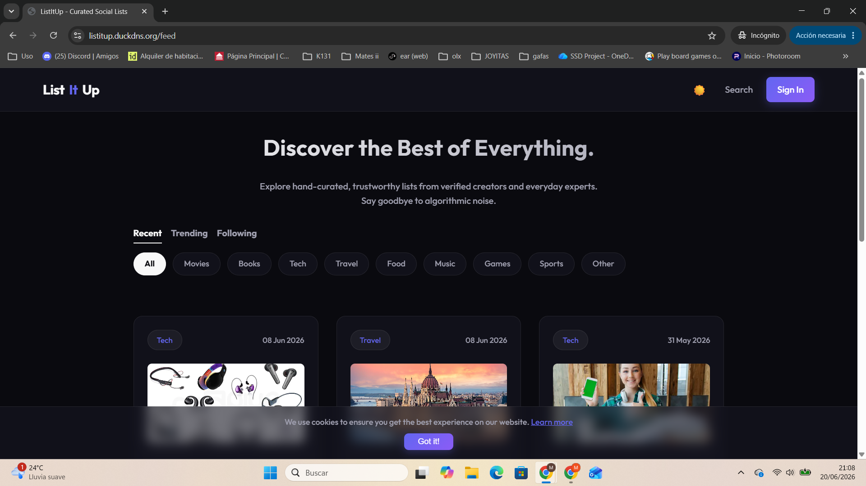

Access and Rectify:
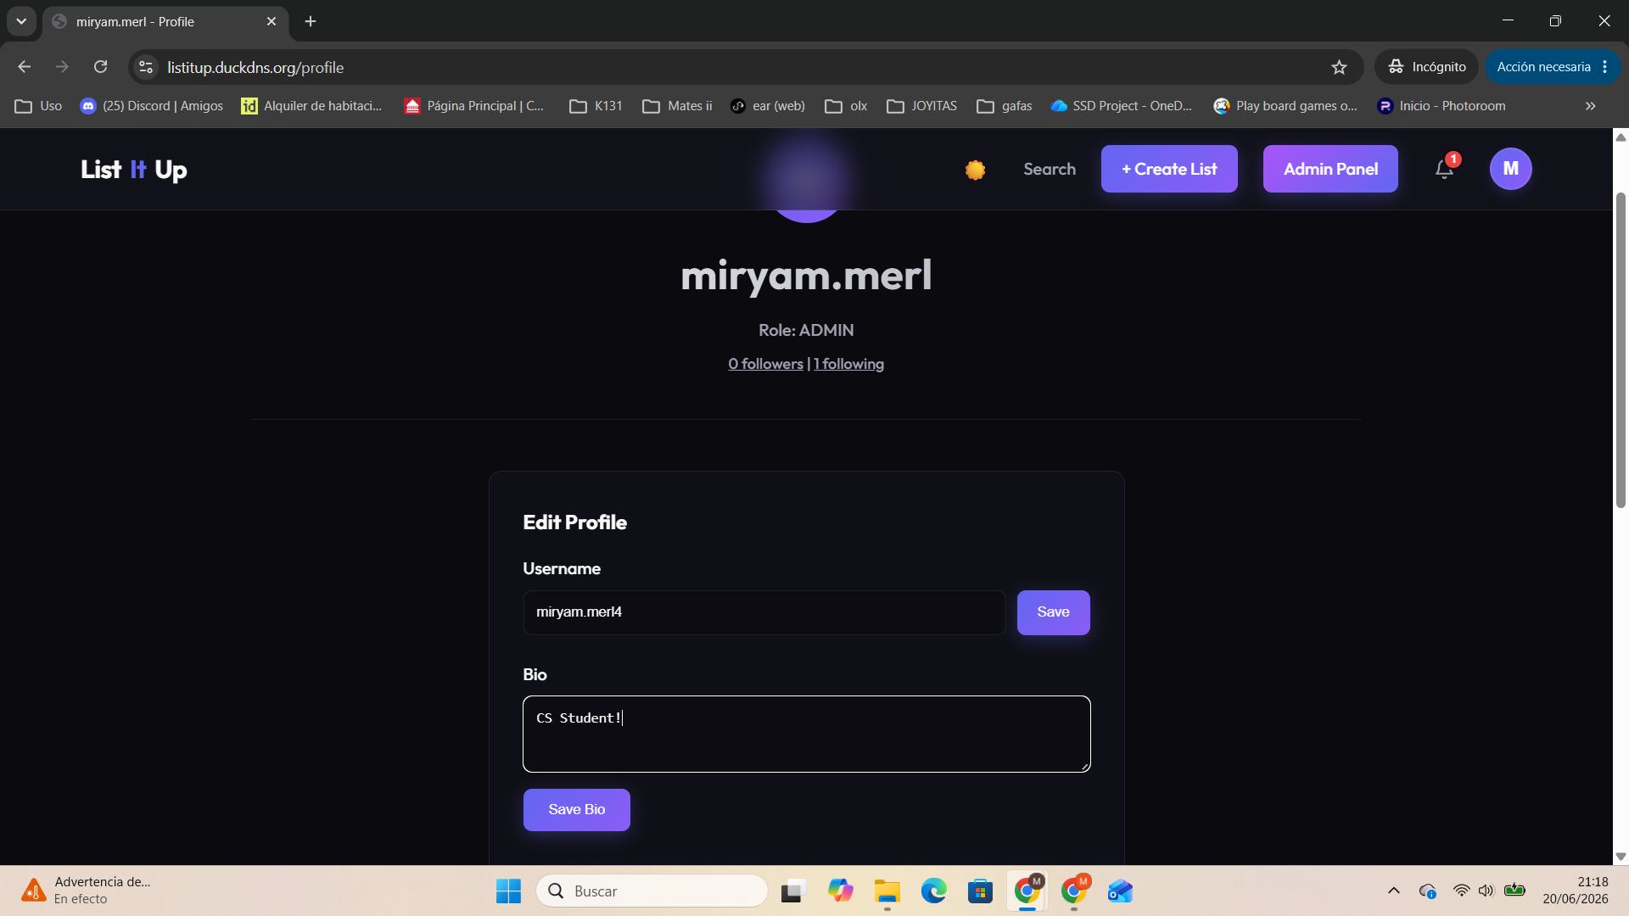
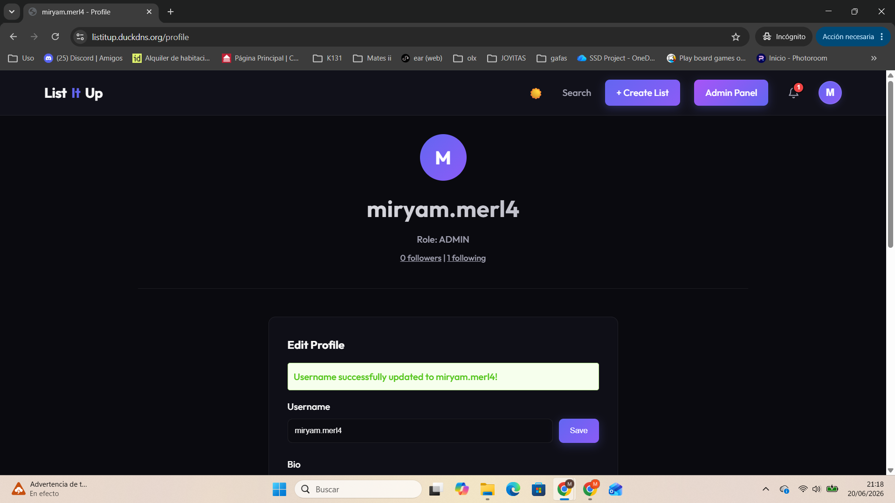

After Deletion:
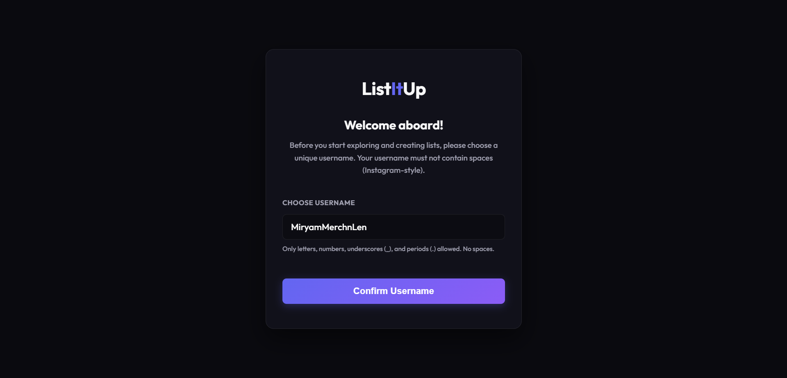

NF5 - Task Completion Rate
- Type: Usability
- Description: At least 80% of pilot users must be able to complete the core create-and-publish-list task without any staff assistance, measured during moderated usability sessions.
- Verification Method: Moderated usability testing sessions were made by 5 pilot users. Participants were instructed to complete the core "create-and-publish-list" task. Sessions were observed in real-time to ensure no staff assistance or guidance was provided. Success was recorded as a binary pass/fail based on independent completion.
- Test Results: 5 out of 5 pilot users (100%) successfully completed the core task of creating and publishing a list without any staff assistance. This result exceeds the minimum requirement of an 80% completion rate. Task execution times and minor user feedback were documented during the observation.

NF6 - Cross-Browser Responsiveness
- Type: Compatibility / Responsiveness
- Description: The UI must render correctly and be fully functional across the two most recent stable versions of Chrome, Firefox, and Safari on both desktop and mobile viewports.
- Verification Method: Manual execution of core user flows across the two latest stable versions of Chrome, Firefox, and Safari on both desktop and mobile viewports. Visual and functional verification was documented using screenshots.
- Test Results: The UI renders correctly and is fully functional with no layout breaks across all specified browsers and devices.

Google Chrome
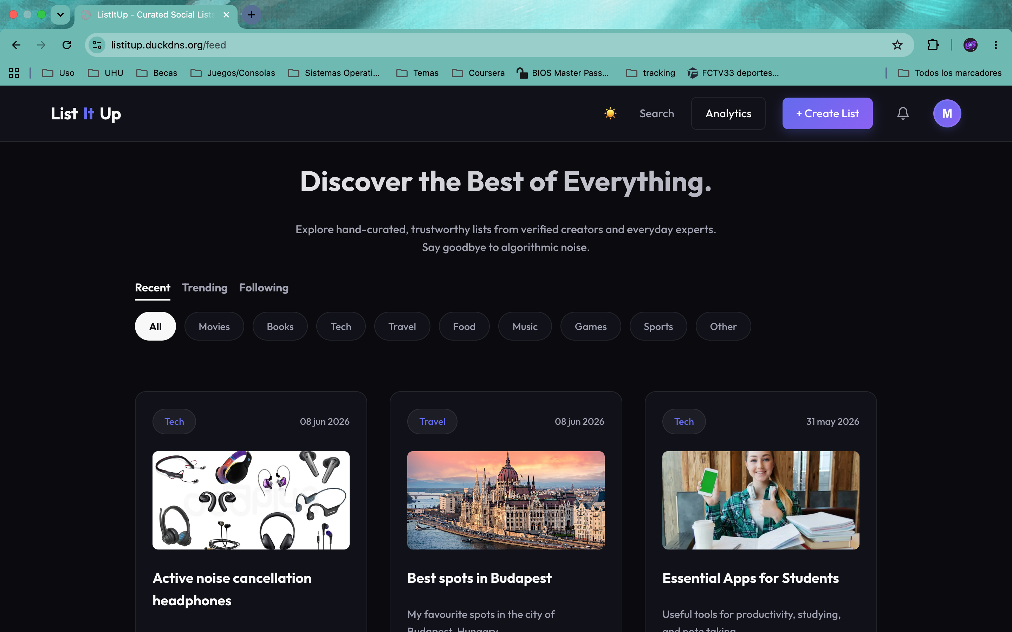

Safari
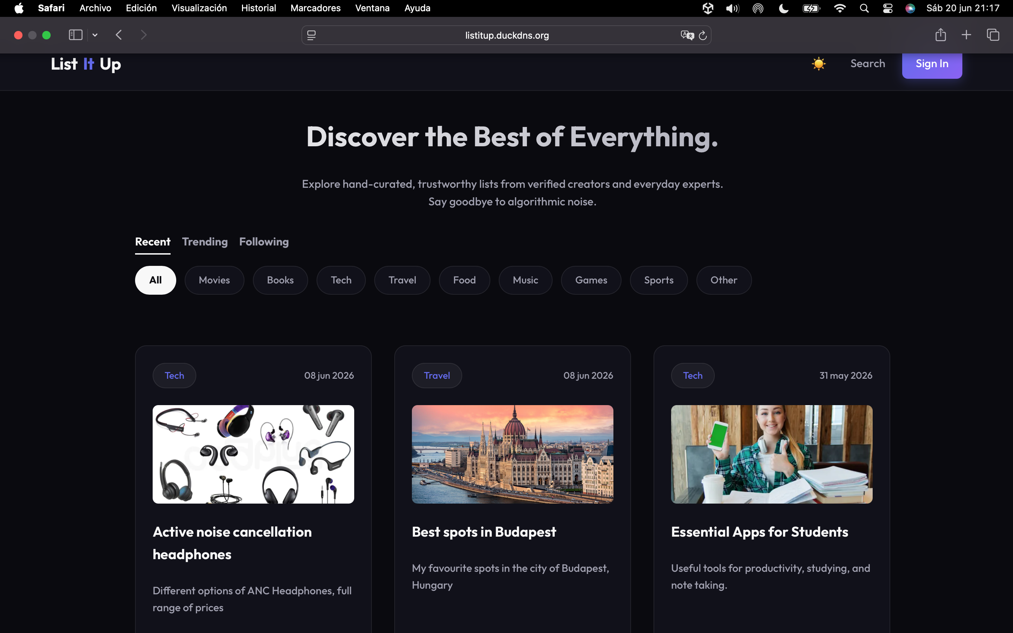

Firefox
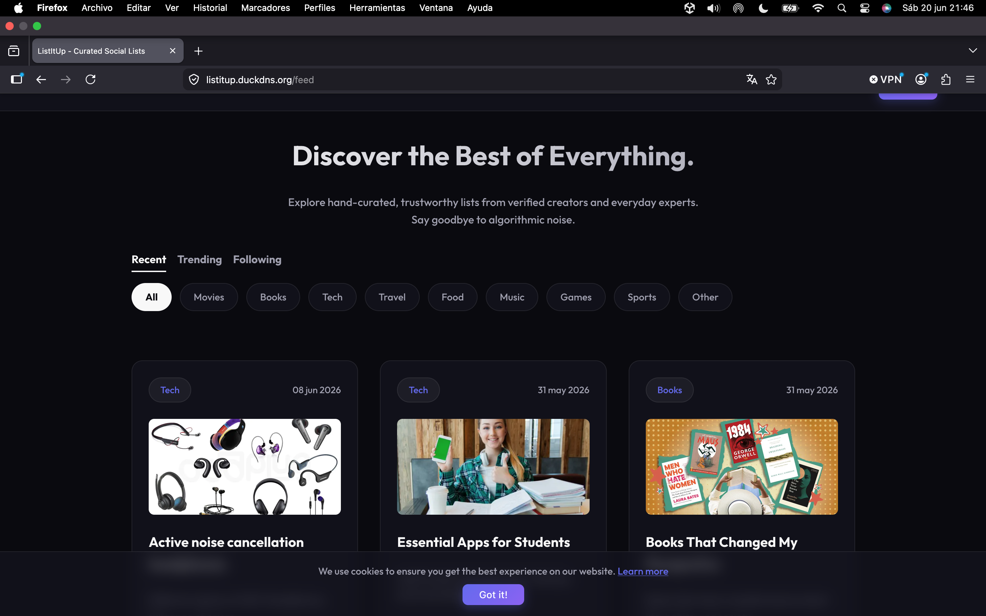

Mobile phone (Safari, Chrome and Brave)
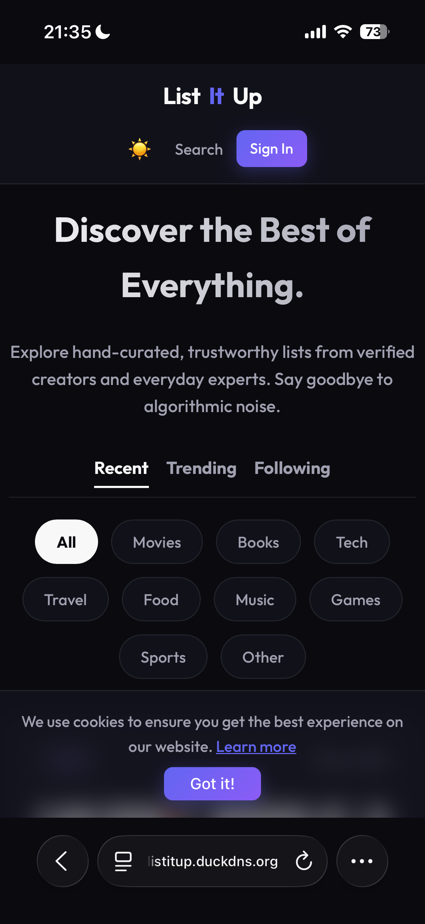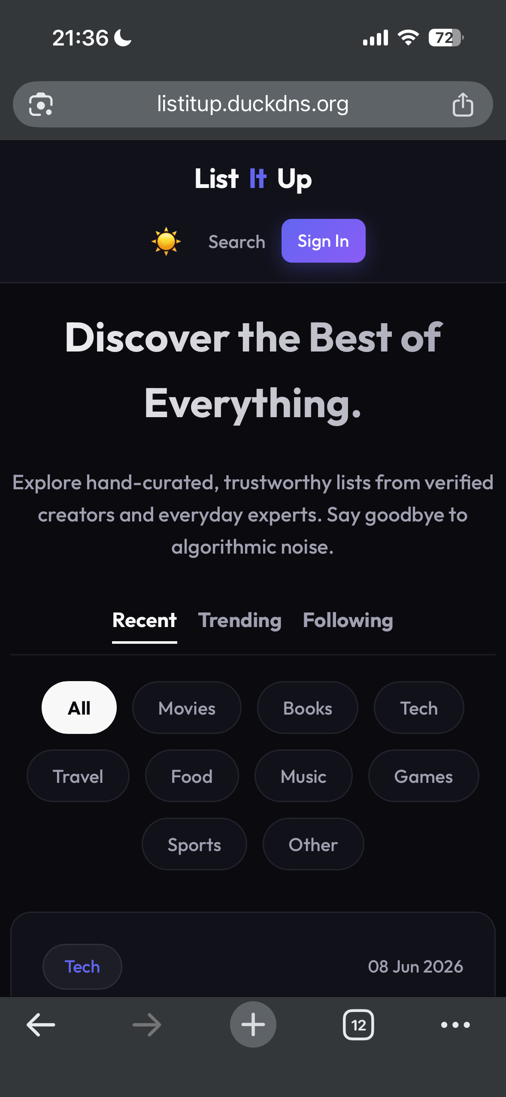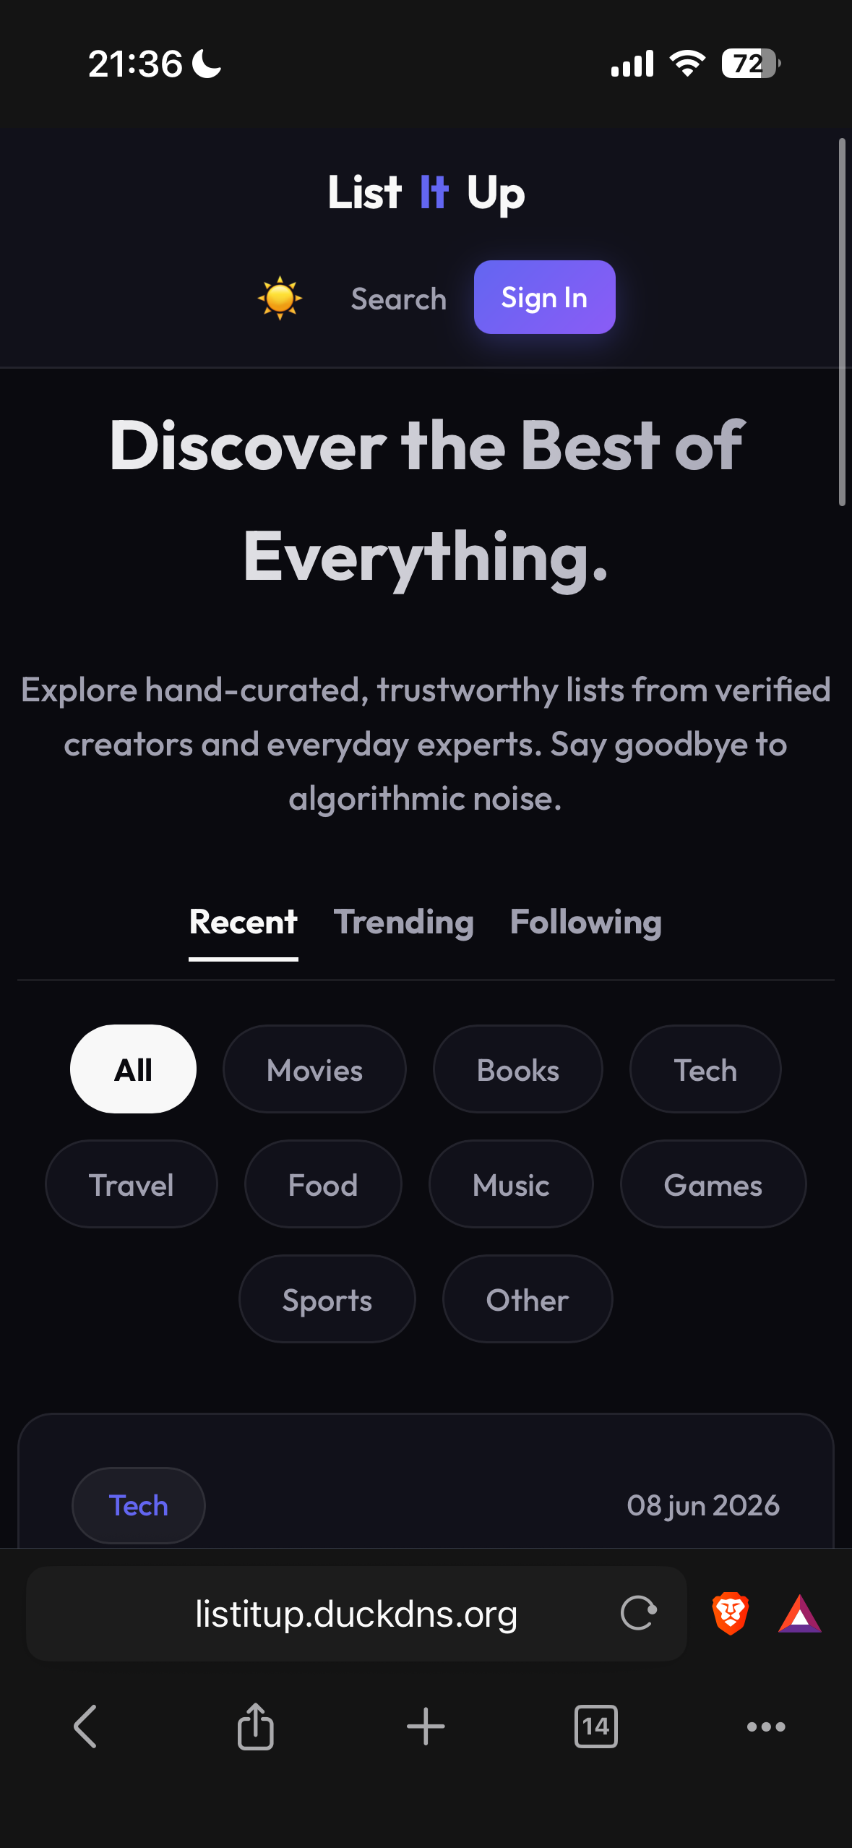

NF7 - OAuth 2.0 Social Login
- Type:
- Security / Authentication
- Description: The platform must support user authentication exclusively via OAuth 2.0 (Google and GitHub). No platform-specific passwords are stored or managed.
- Verification Method: Manual execution of the complete OAuth 2.0 authentication flow for both Google and GitHub providers. Verification includes confirming successful redirection, user consent handling, and session creation upon callback. Visual inspection confirmed the absence of any local password-based registration forms.
- Test Results: Users can successfully authenticate using both Google and GitHub OAuth providers.

Login Panel
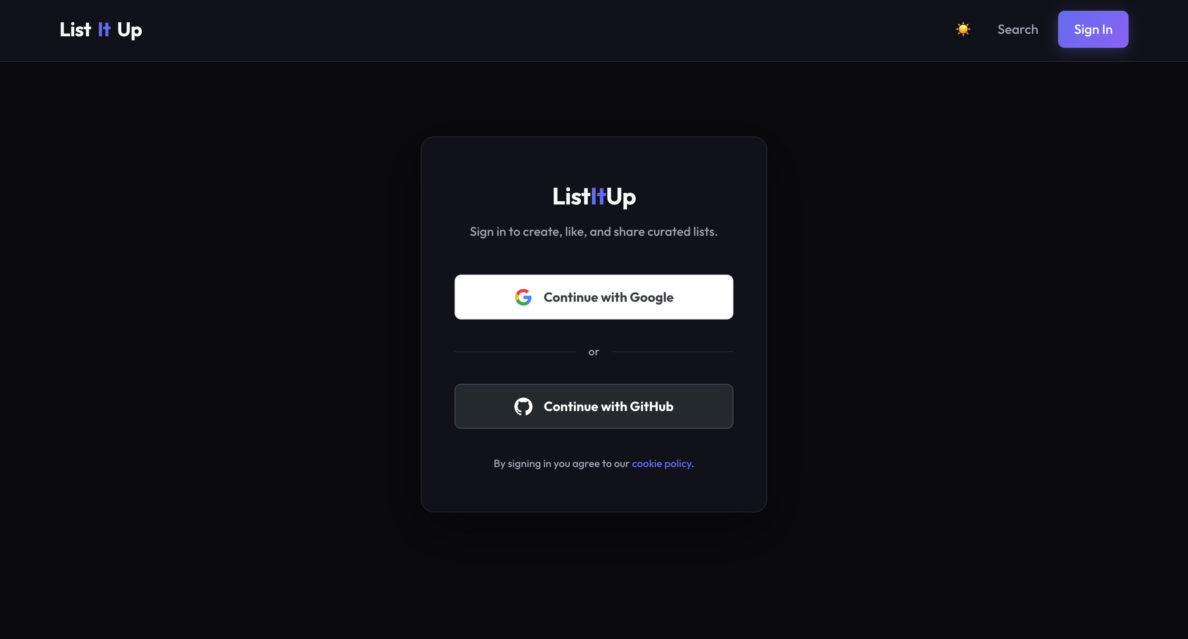
Github Option Panel
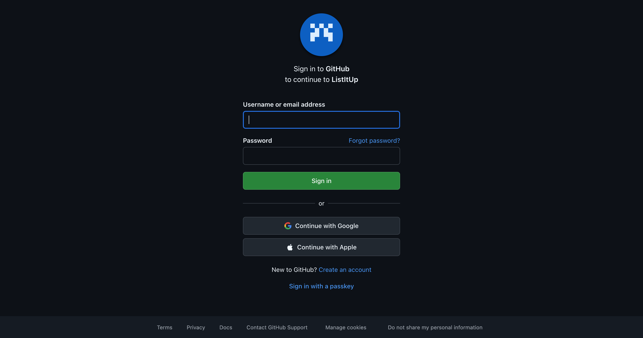
Google Option Panel
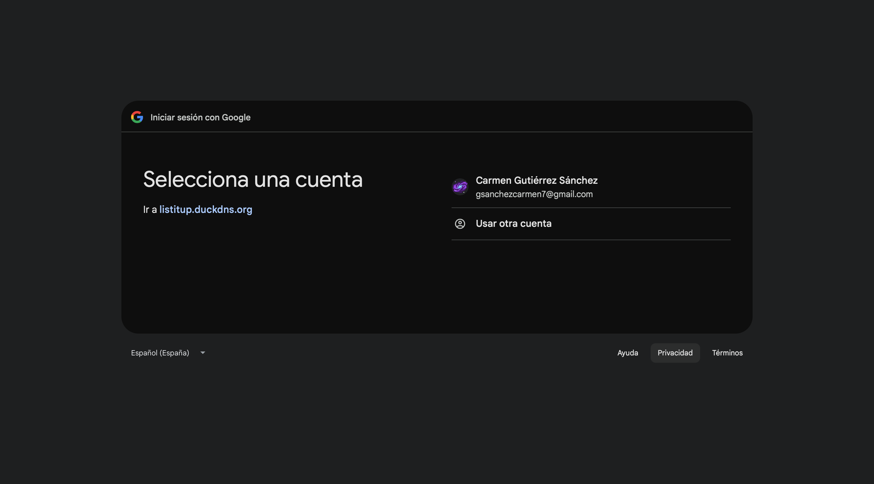

NF8 – User Profile Management
- Type: Usability
- Security / Authentication
- Description: Each user must have a publicly visible profile containing a username, biography, and profile picture. Verified creators must additionally display a verification badge on their profile.
- Verification Method: Inspect a registered user profile: verify that username, biography and profile picture fields are displayed. Log in as a verified creator and confirm that the verification badge appears on the profile page.
- Test Results: To verify the user profile management requirements, a manual inspection of the platform's public profile views was performed.
  - Standard Profile Fields: Reviewing a registered user's profile page confirmed that the system correctly renders the required public attributes: username, biography, and profile picture.
  - Verification Badge: Inspection of a profile belonging to a user with verified status confirmed that the dedicated verification badge is dynamically displayed on the page interface, visually distinguishing verified creators from standard accounts.

Profile Info Display:
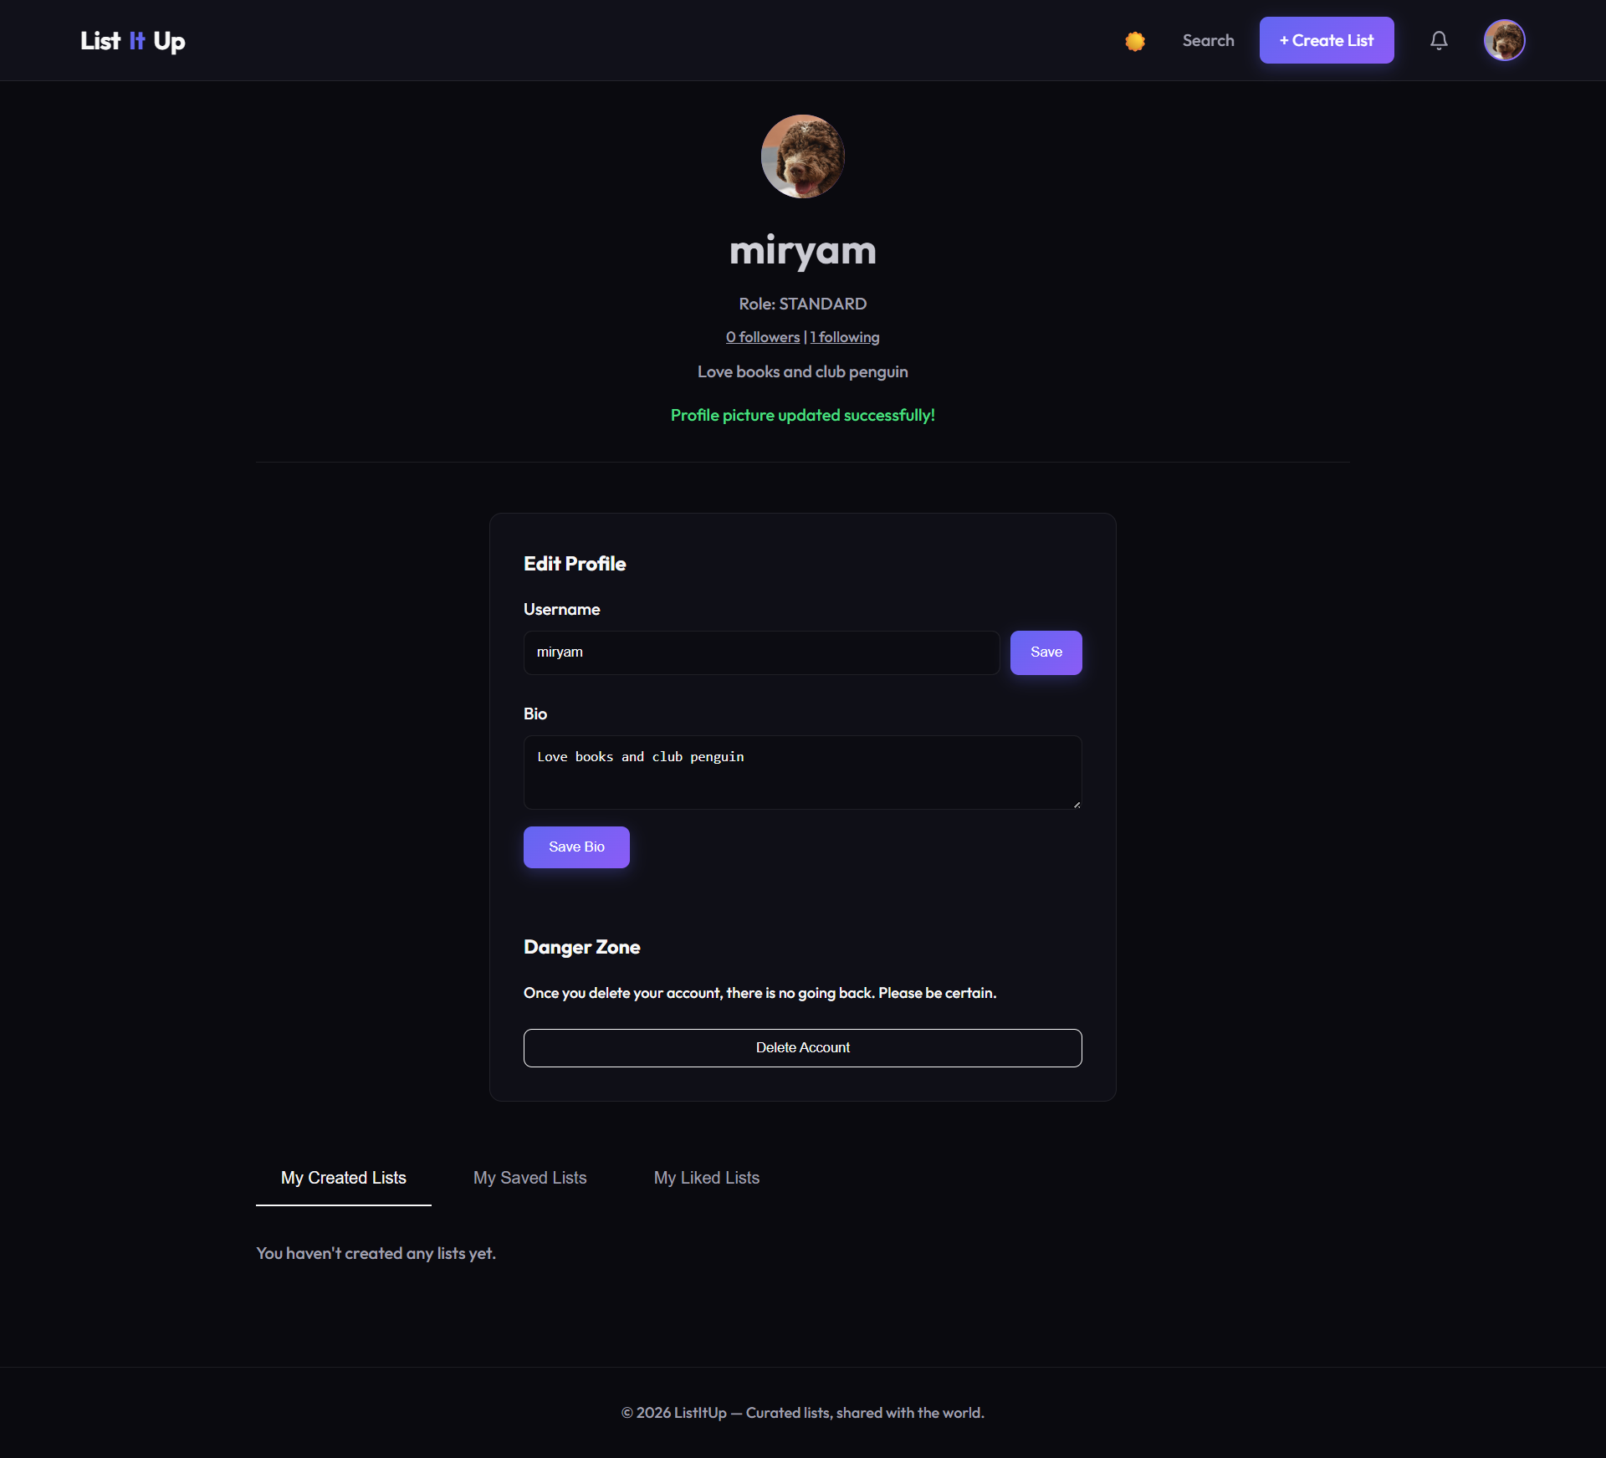

Verified Profile:
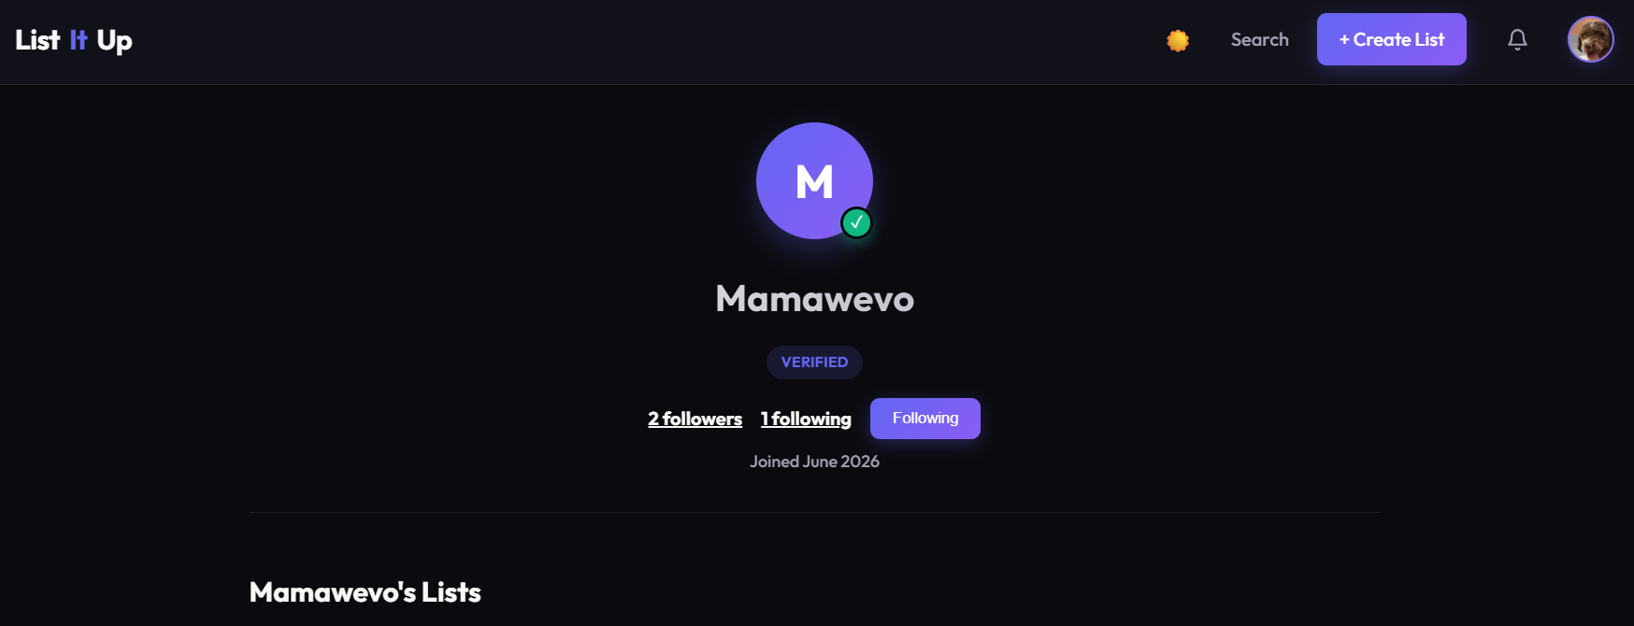

    - Remaining Tests

We did a suite of automated unit and integration tests that have been implemented to ensure the robustness of the system’s bussiness logic, data access, and web layers.
As previously detailed in Section 4.1.3 (D. Test Artifacts), a total of 96 automated tests were developed. These tests are categorized as follows:
- Unit Tests (Service Layer): Isolated tests for UserService, ListService, ItemService, SocialService and AnalyticsService using standard mocking frameworks to validate business rules and calculations independently of the database.
- Integration Tests (Web/Controller Layer): Executed using MockMvc for ListController and AdminController to verify HTTP endpoints, security guards (OAuth2), and role-based access control (STANDARD vs. ADMIN).
- Data Access Tests (Repository Layer): Executed using @DataJpaTest for UserRepository and CuratedListRepository to validate custom database queries, pagination, and data persistane directly against a test database context.

